LAB REPORT

IT3100E

***Full name:*** *Phạm Xuân Tuấn*

***Class:*** *ICT 02 - K68*

***Class code:*** *750816*

***Student ID:*** *20236010*

**OBJECT – ORIENTED PROGRAMING**

**LAB REPORT**

**Lab 02: Object-Oriented Techniques**

**4. Update the Cart class and CartTest class**

Write new methods to implement the following functions:

- Create a new method to print the list of ordered items of a cart, the price of each item, and the total

price. Format the outline as below:

***********************CART***********************

Ordered Items:

1. DVD - [Title] - [category] - [Director] - [Length]: [Price] $

2. DVD - [Title] - ...

Total cost: [total cost]

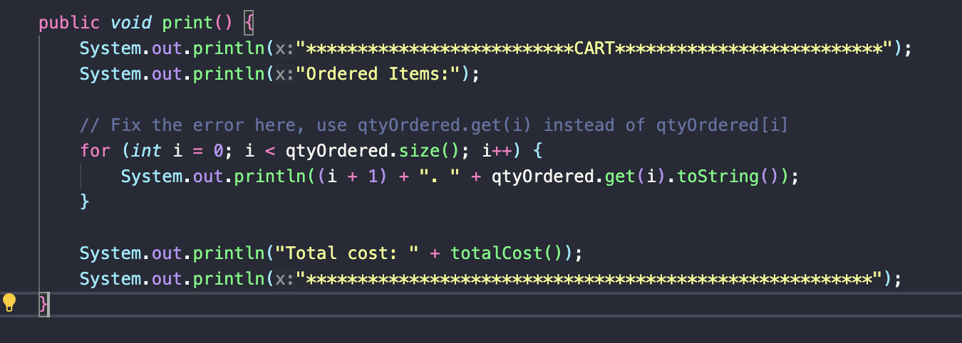

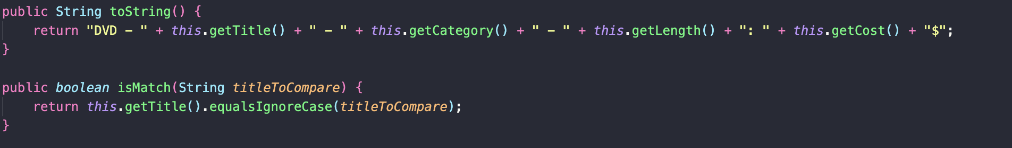

Suggestion: Write a toString() method for the DigitalVideoDisc class. What should be the

return type of this method?

Answer: The toString() method is used to provide a string representation of an object. In this case, you can create a toString() method for the DigitalVideoDisc class that returns a string with the desired format for the DVD. This will help print the details of the ordered items in the cart

Search for DVDs in the cart by ID and display the search results. Make sure to notify the user if no

match is found.

- Search for DVDs in the cart by title and print the results. Make sure to notify the user if no match is

found. Refer to the problem statement in Lab02 for the matching rule( Section 4).

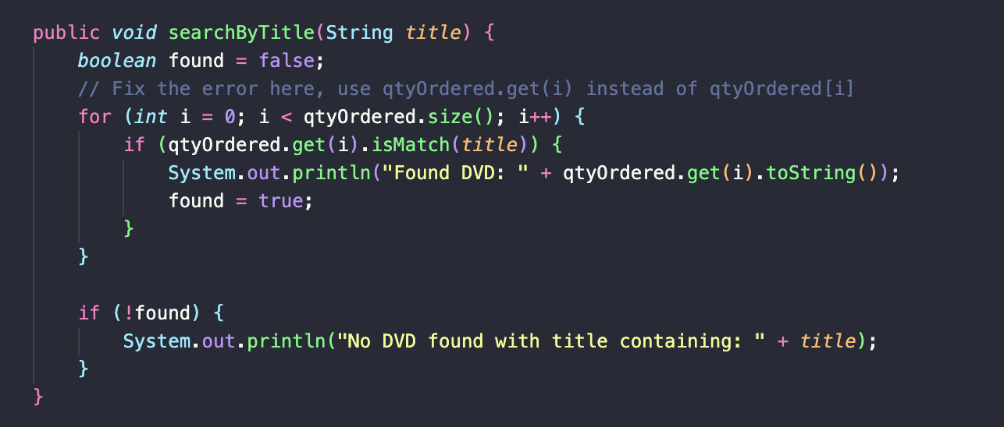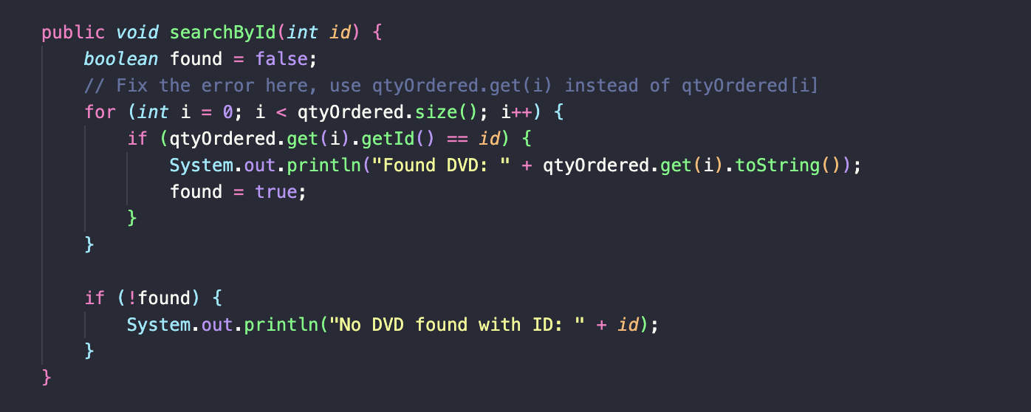

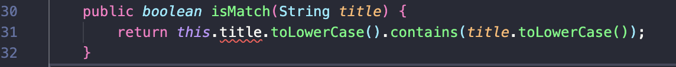

In the CartTest class, write codes to test all methods you have written in this exercise. You should

create sample DVDs and carts, like in this code snippet:

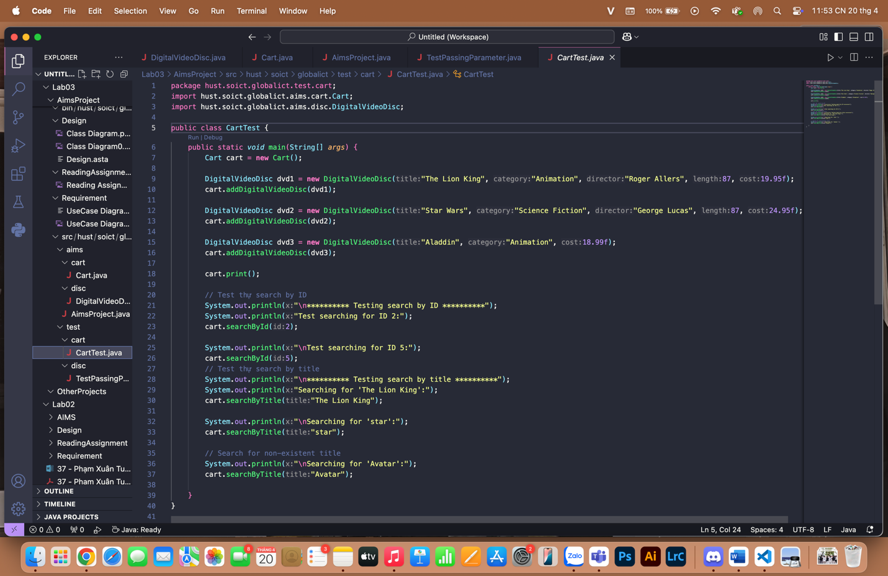

And the result is:

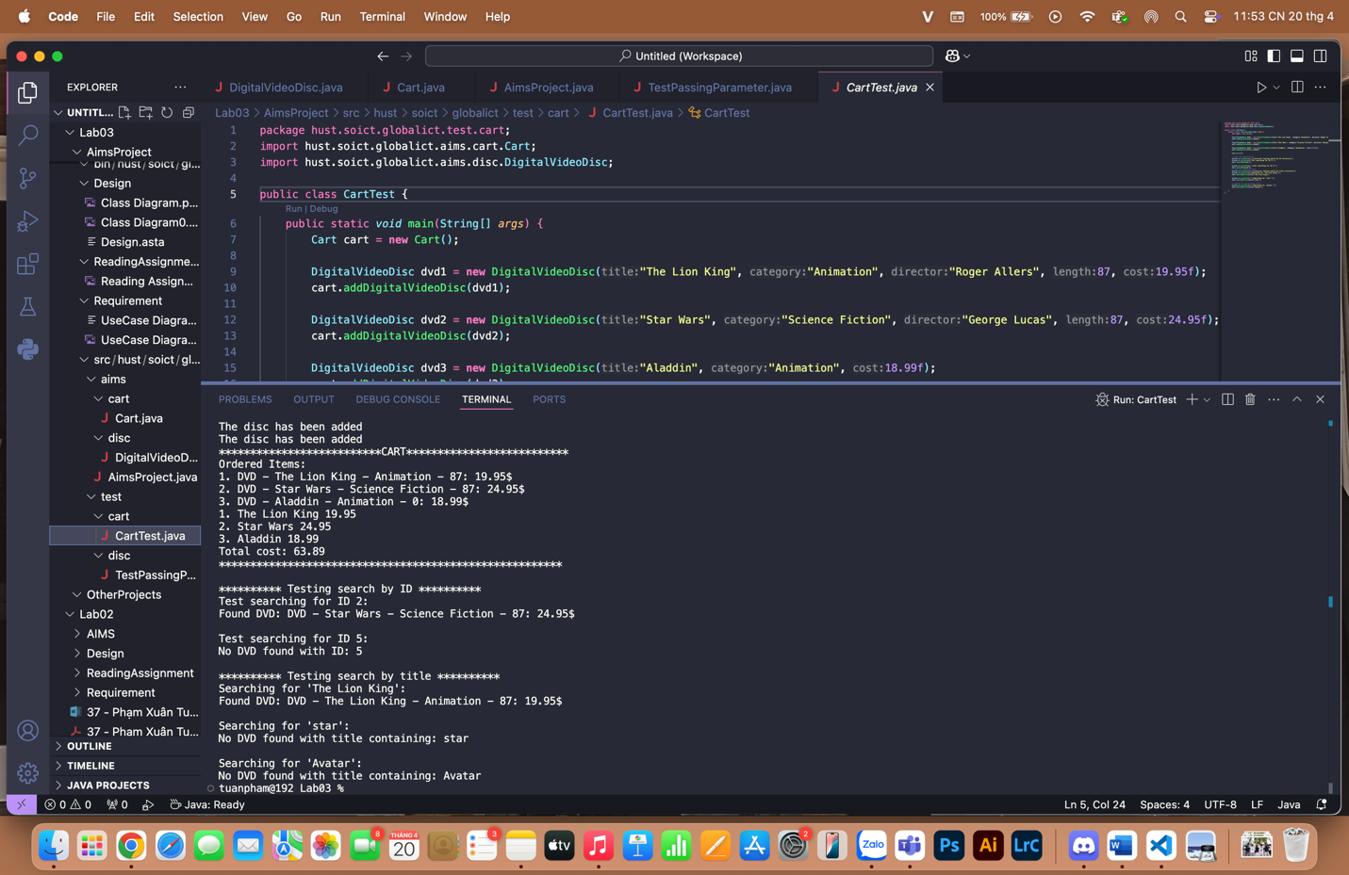

**5. Implement the Store class**

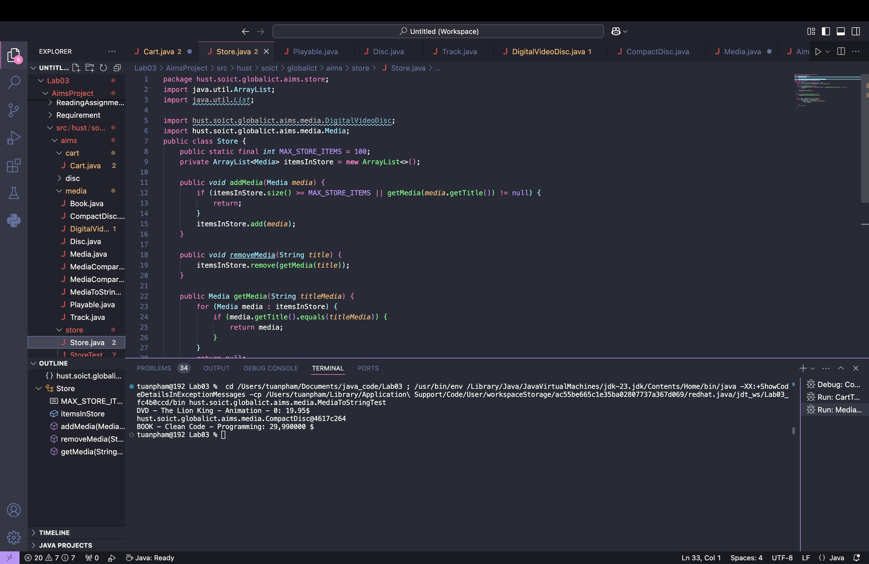

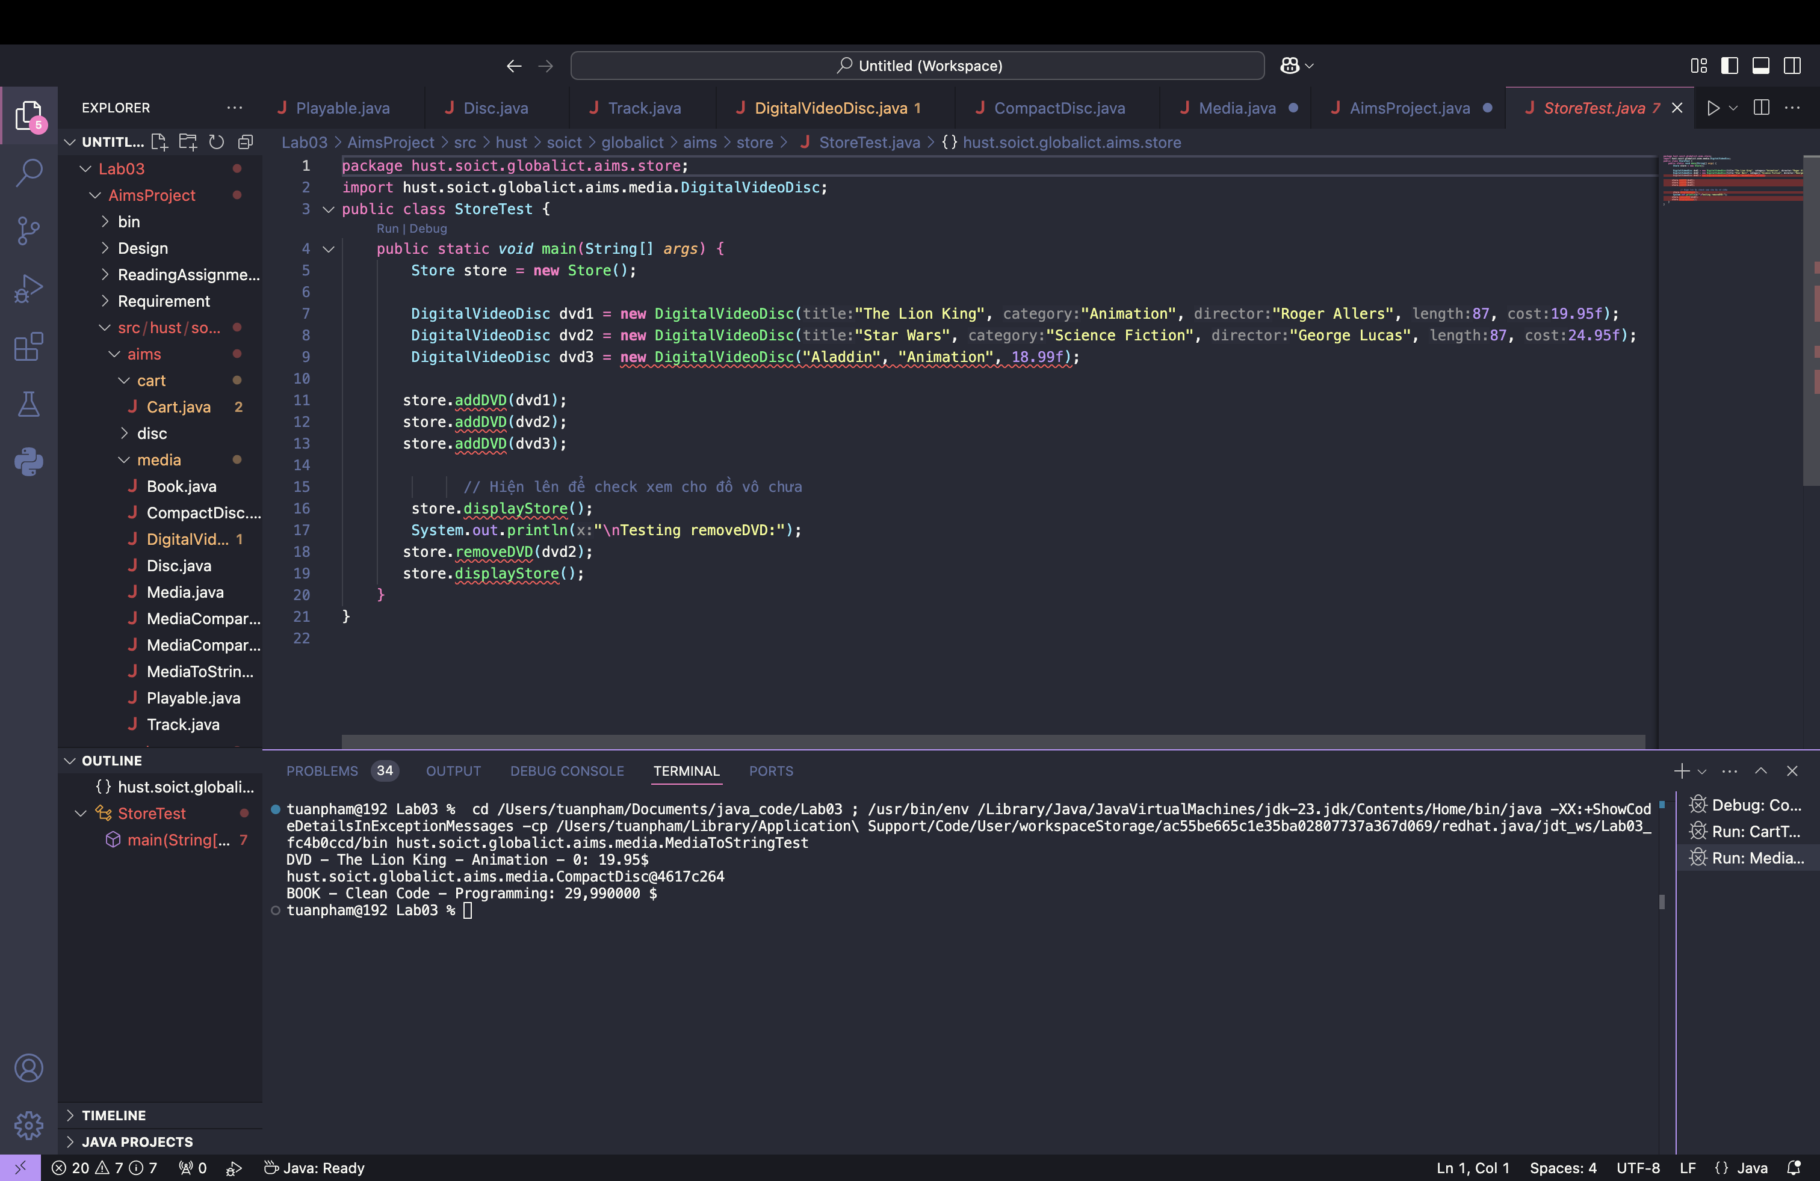

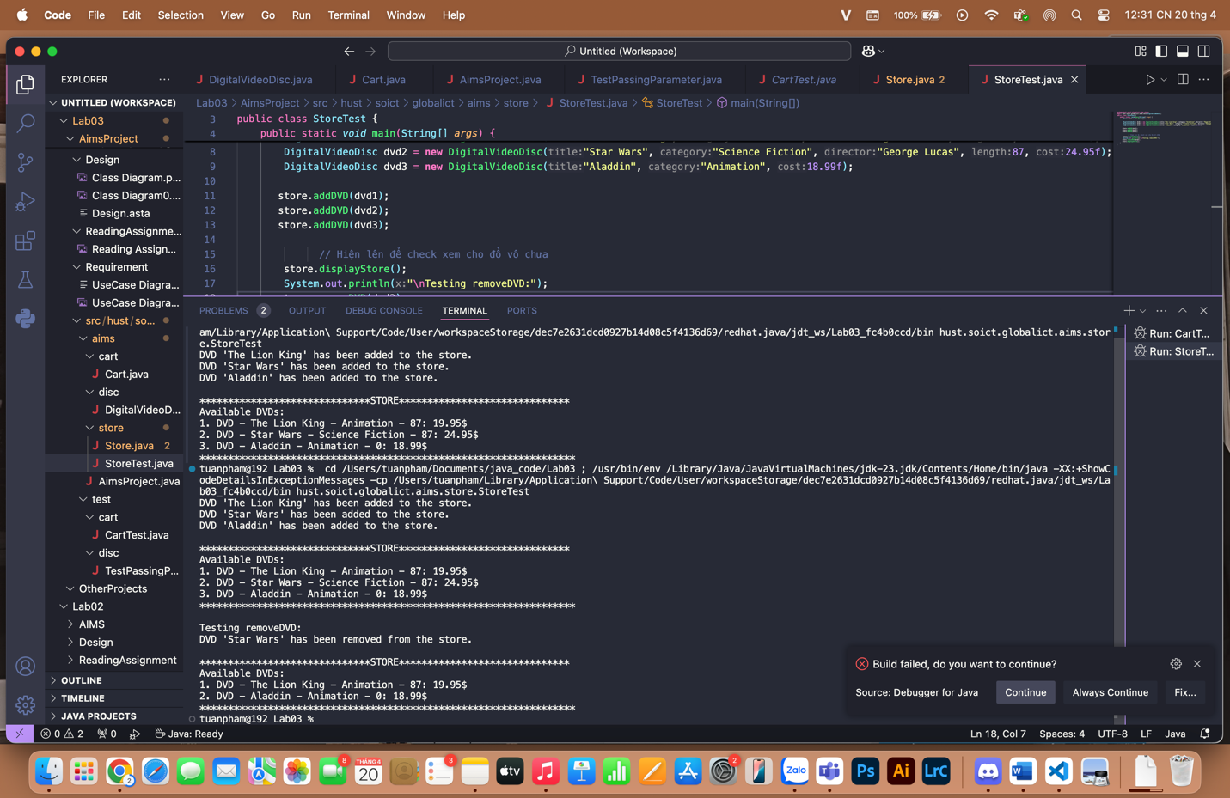

**6. String, StringBuilder and StringBuffer**

**Create a new class ConcatenationInLoops to test the processing time to construct String using + operator, StringBuffer and StringBuilder.**

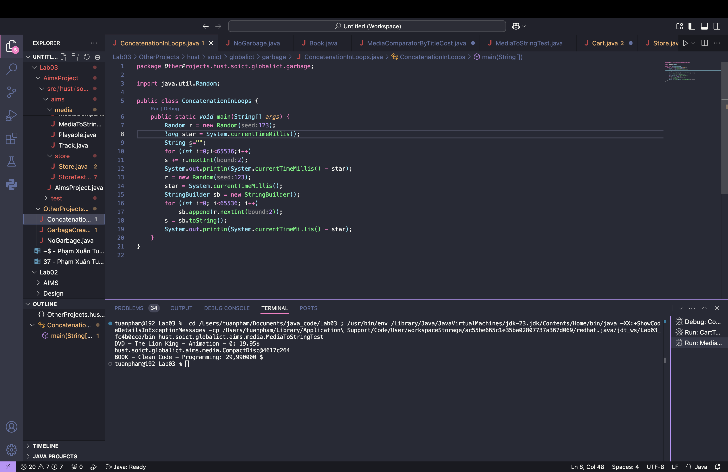

**Create a new class GarbageCreator. Create “garbage” as much as possible and observe when**

**you run a program (it should let the program hang or even stop working when there is too much**

**“garbage”). Write another class NoGarbage to solve the problem.**

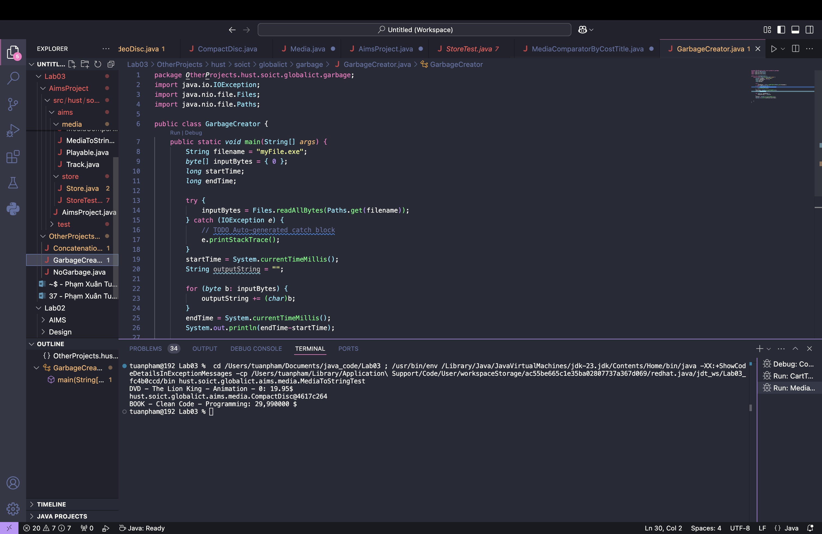

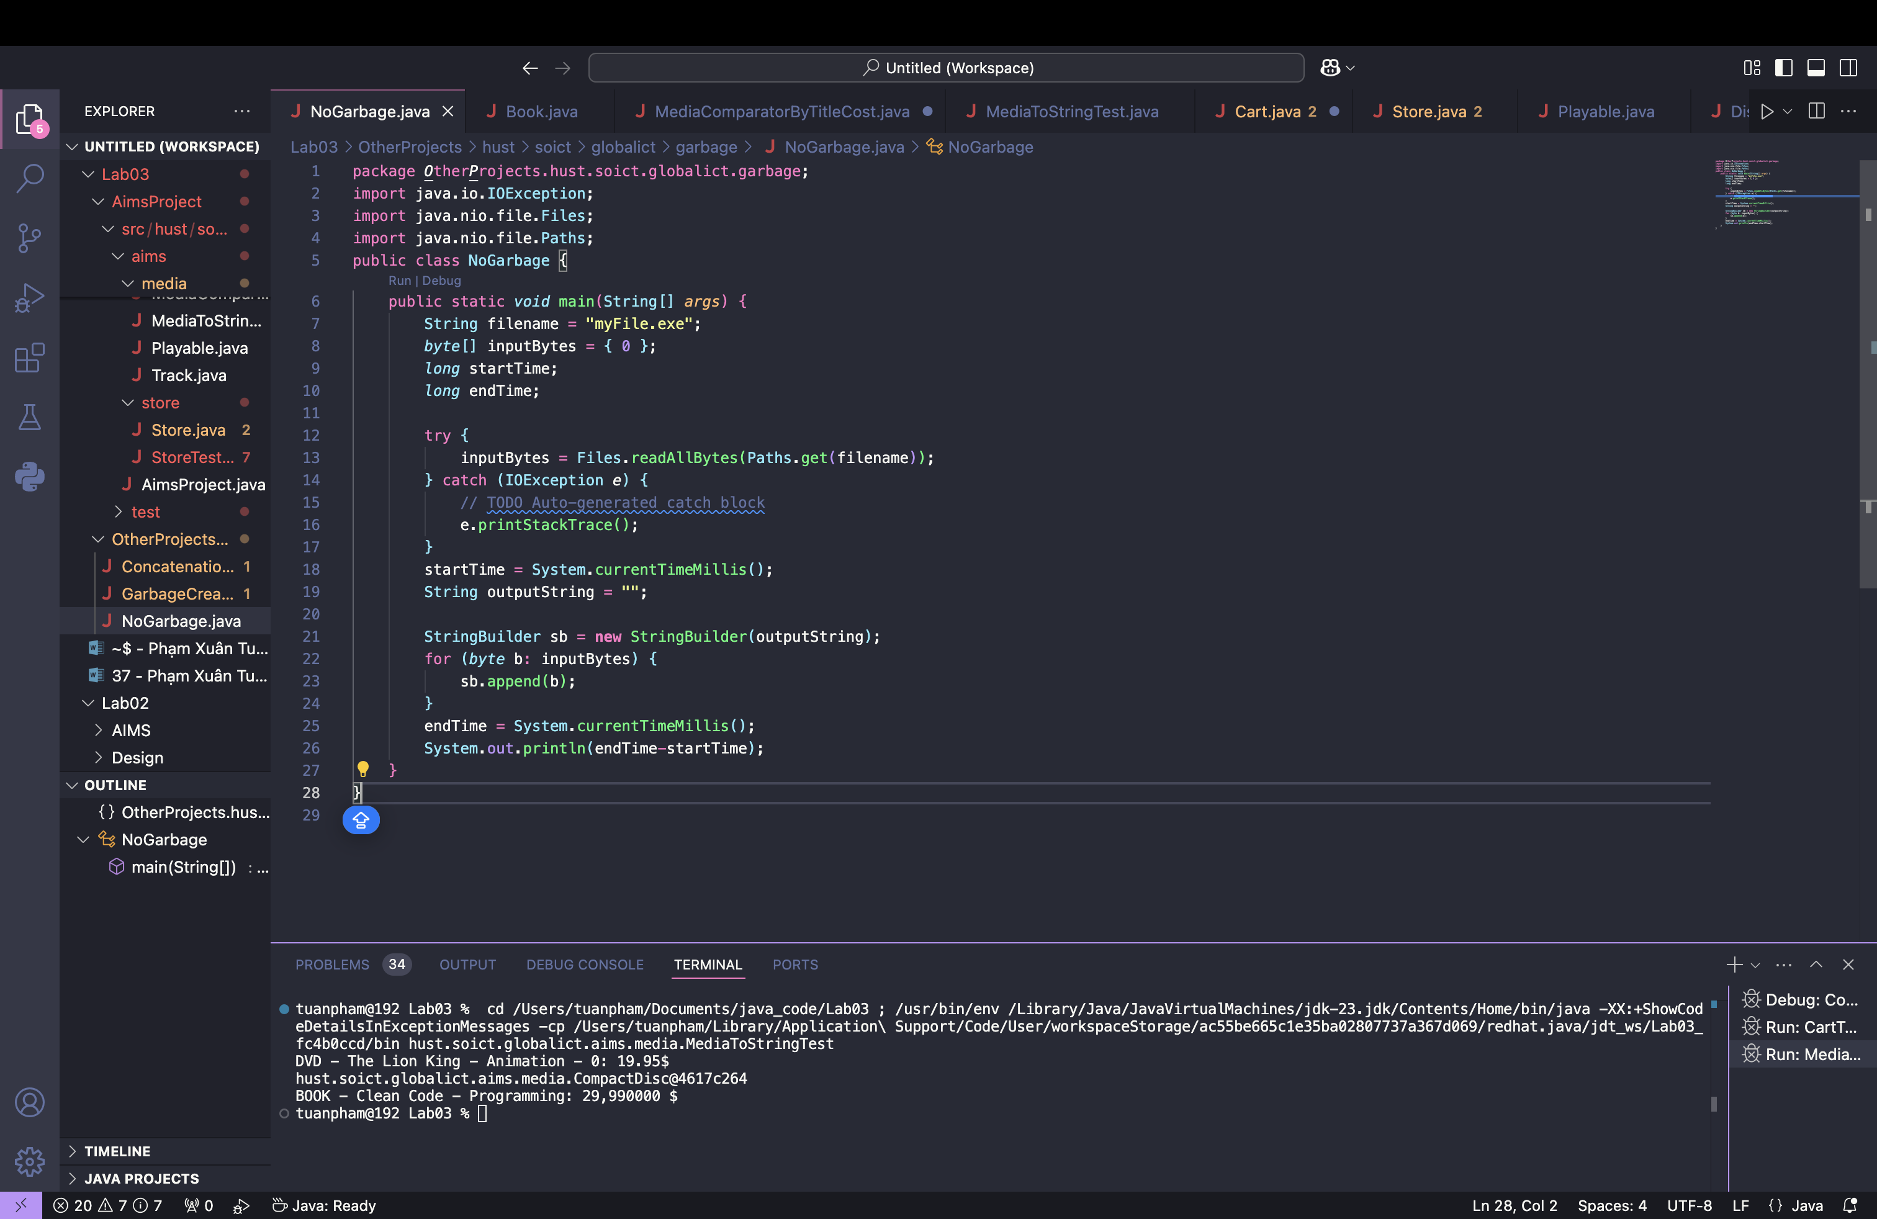

**8. Implementation of the Book class**

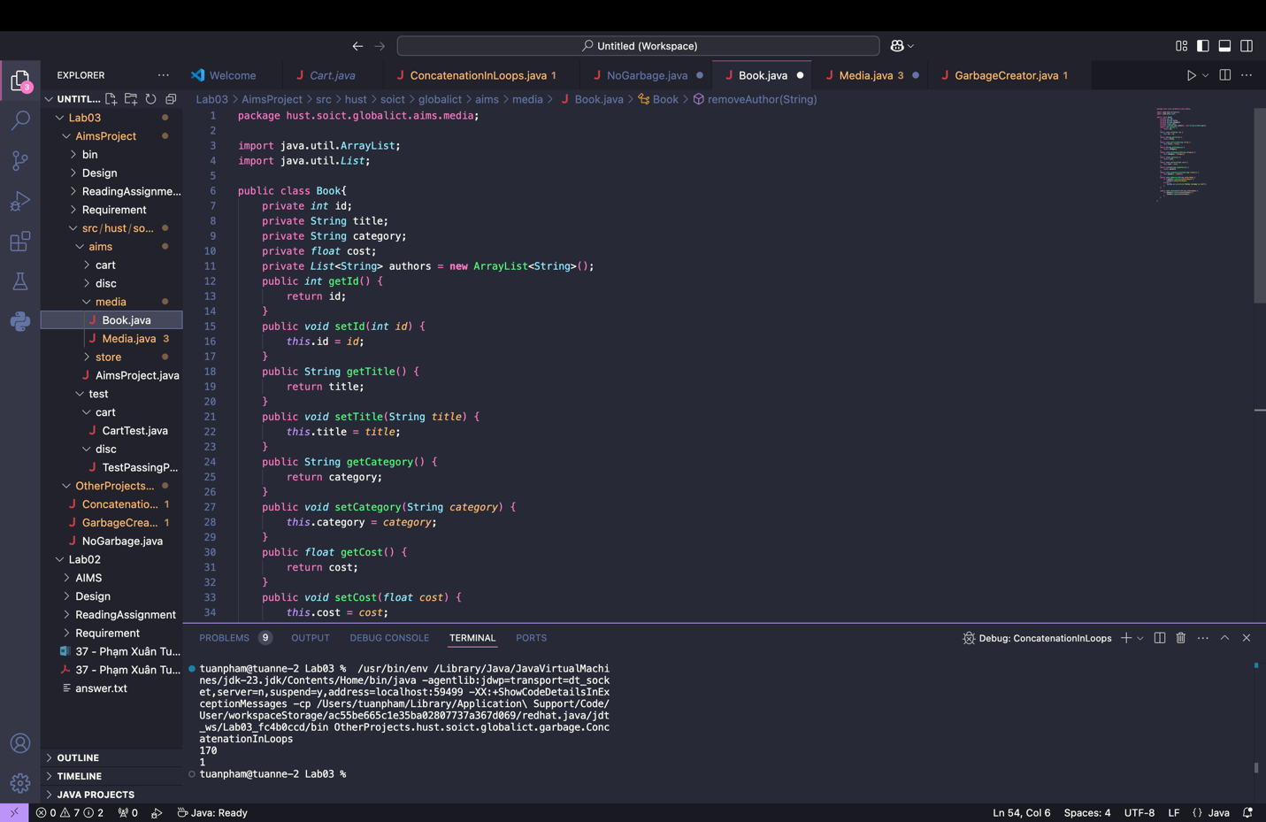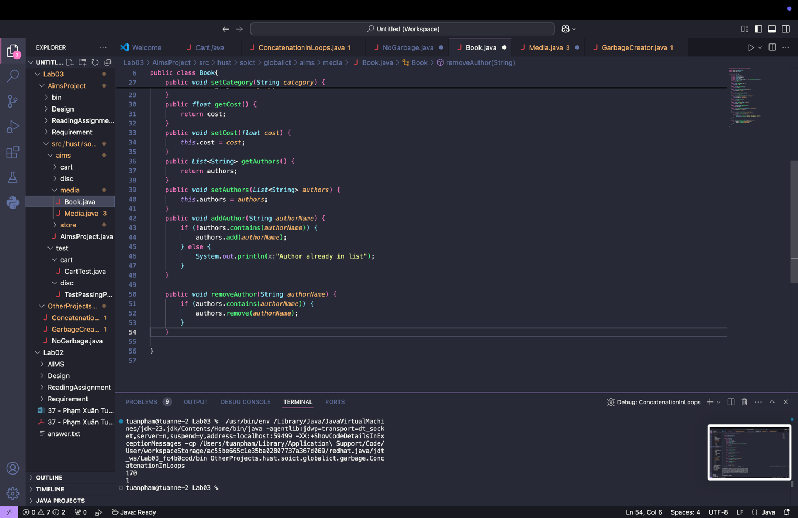

**9. Implementation of the abstract Media class**

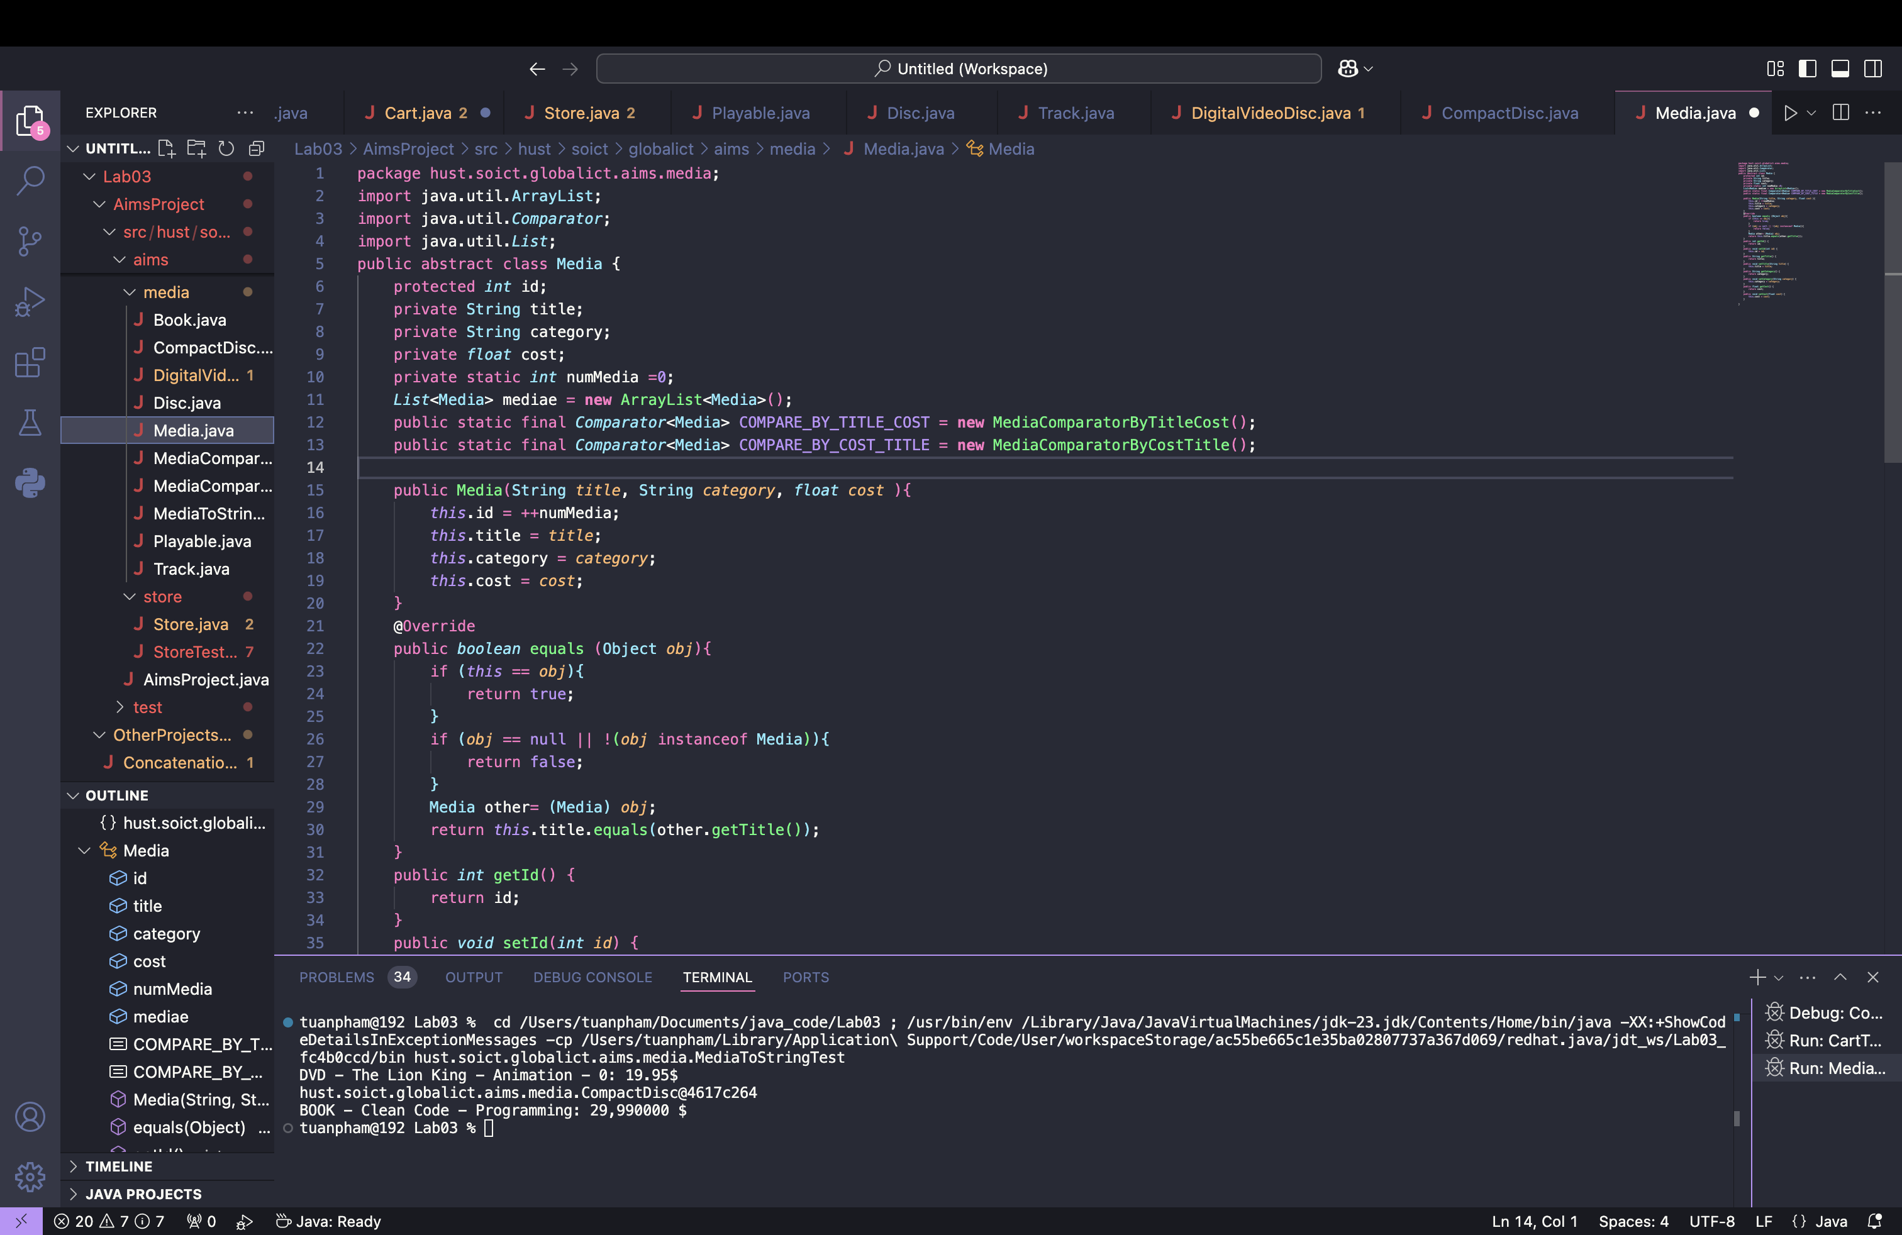

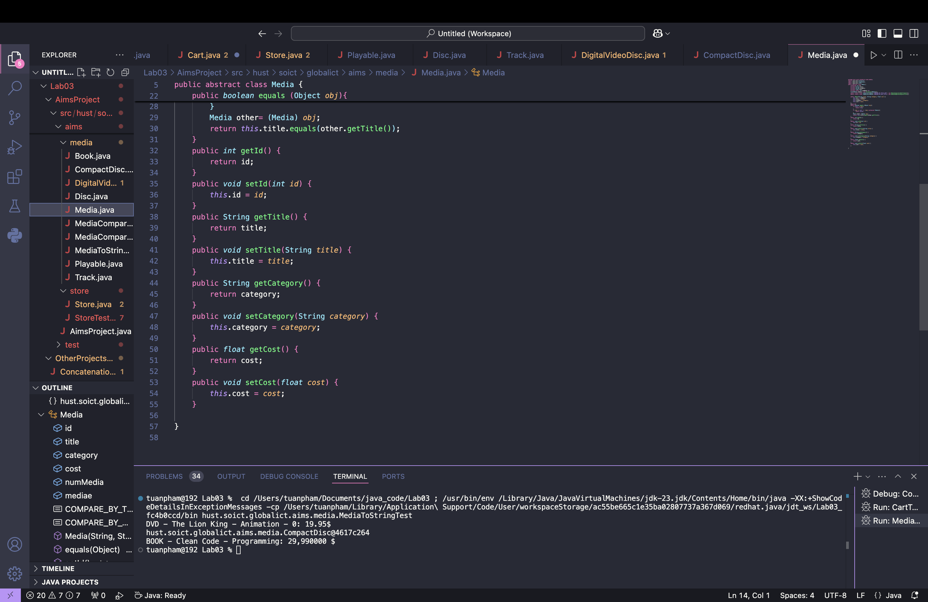

Remove fields and methods from Book and DigitalVideoDisc classes

o Open the Book.java in the editor

o Locate the Outline view on the right-hand side

o Select the fields id, title, category, cost and their accessors & mutators (if exist)

o Right click the selection and select Delete from the pop-up menu

o Save your changes

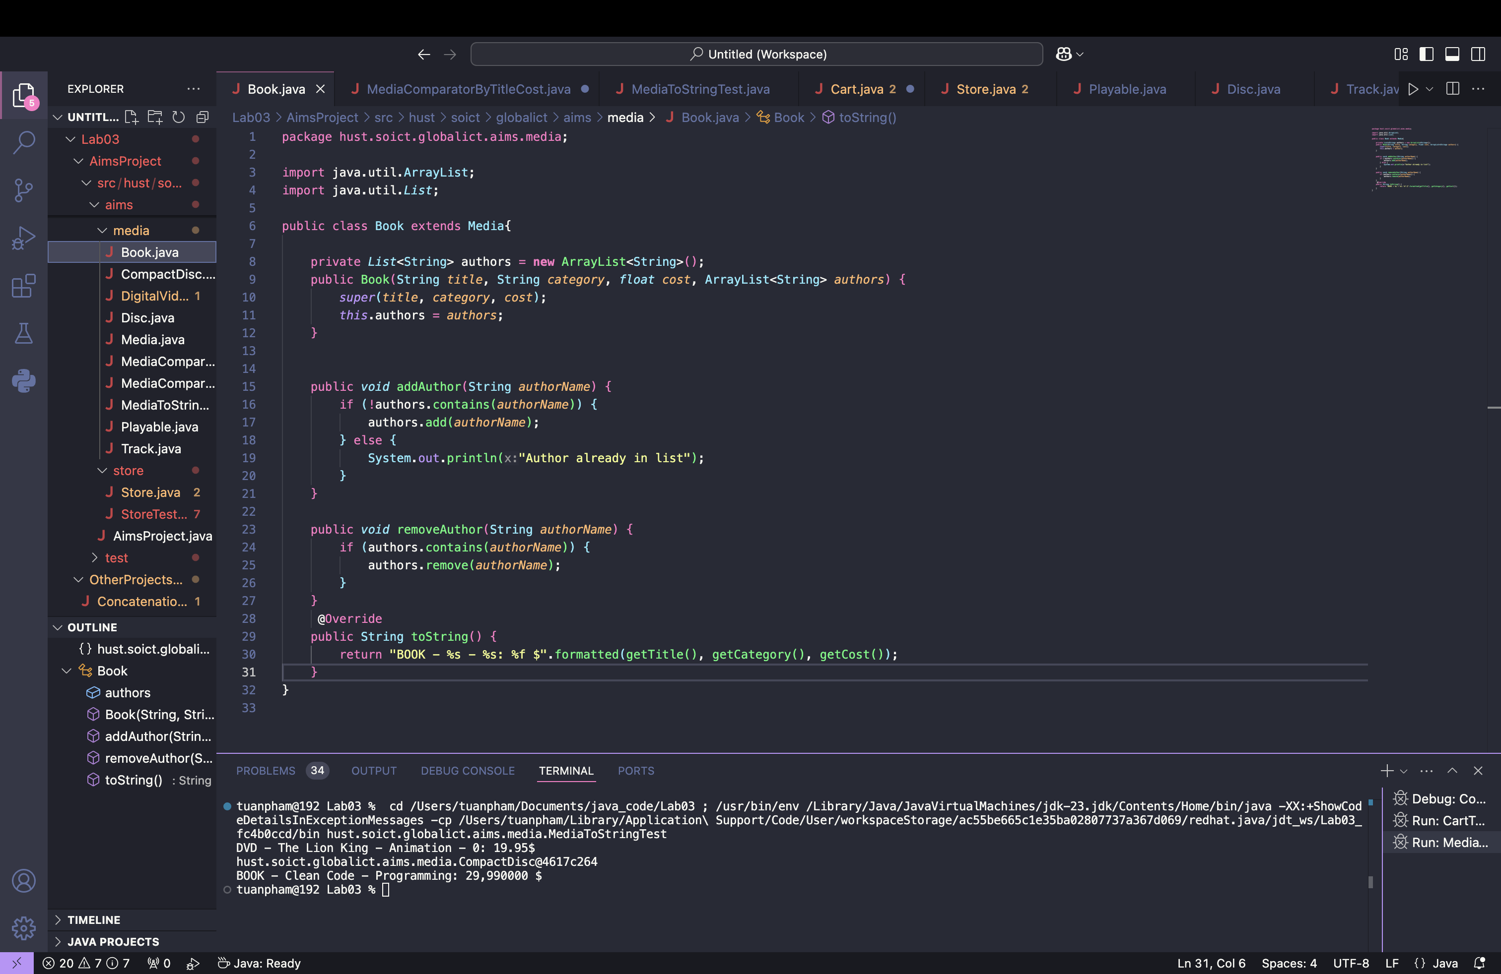

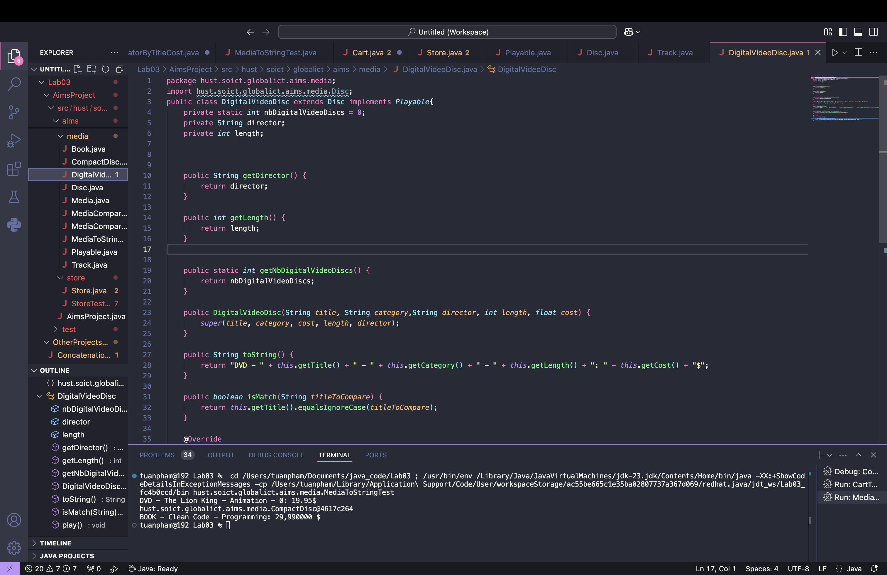

**10. Implementation of the CompactDisc class**

**10.1 Create the Disc class extending the Media class**

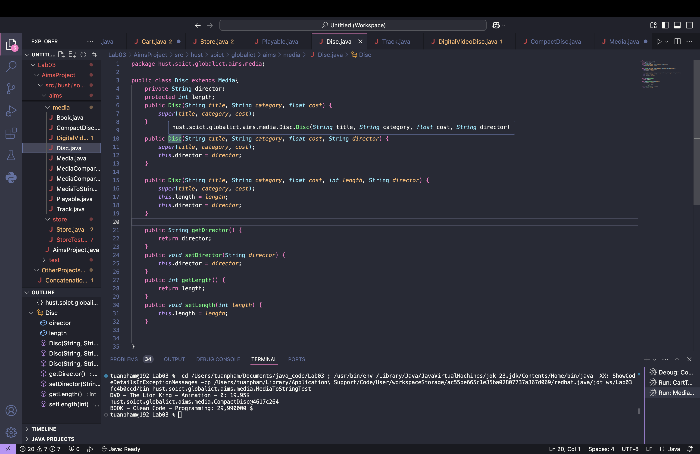

**10.2 Create the Track class which models a track on a compact disc and will store information including the title and length of the track**

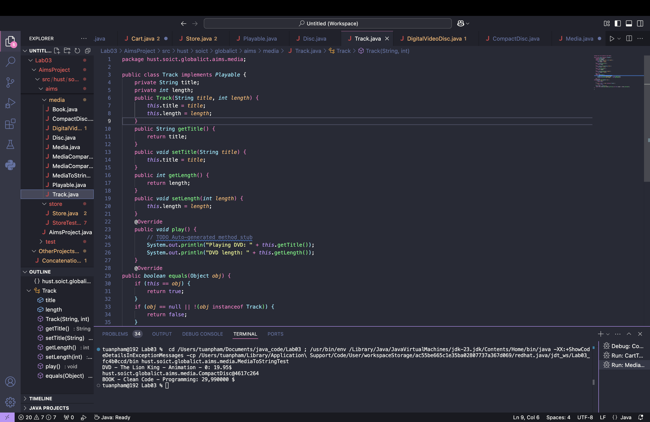

**10.3 Update the CompactDisc class**

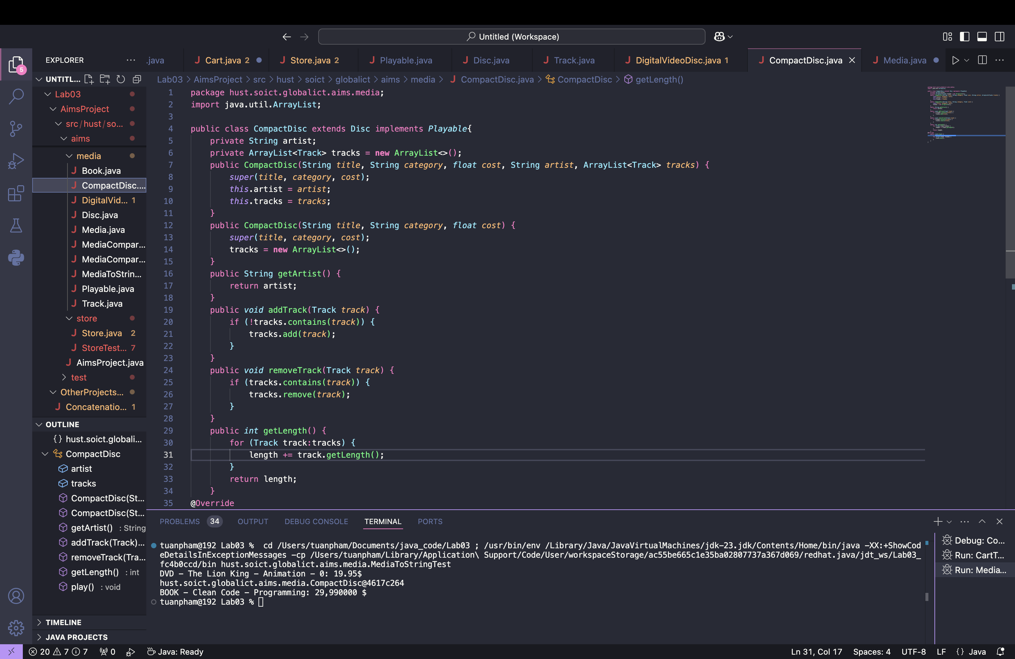

**11. Implementation of the Playable interface**

Create Playable interface, and add to it the method prototype: public void play();

- Save your changes

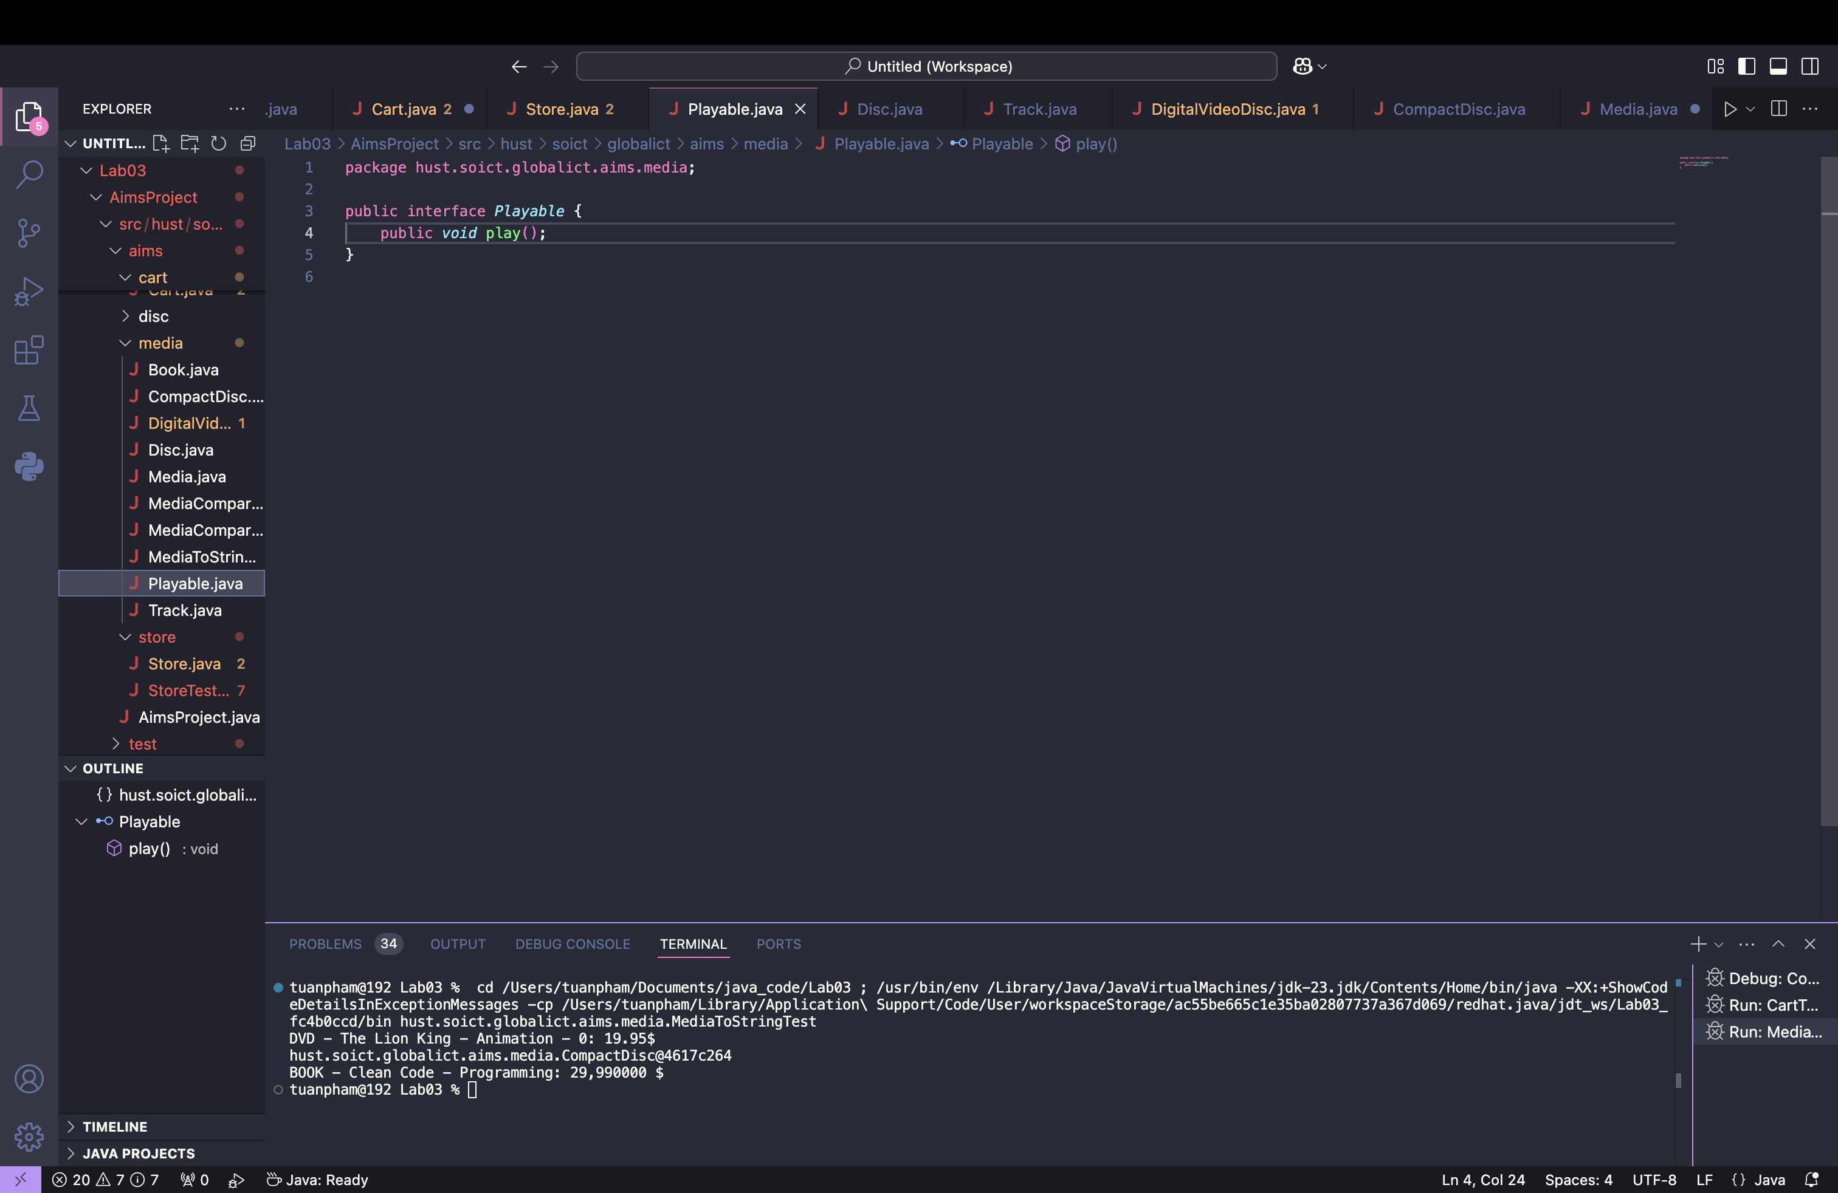

**Implement the Playable with CompactDisc, DigitalVideoDisc and Track**

**Implement play() for DigitalVideoDisc and Track**

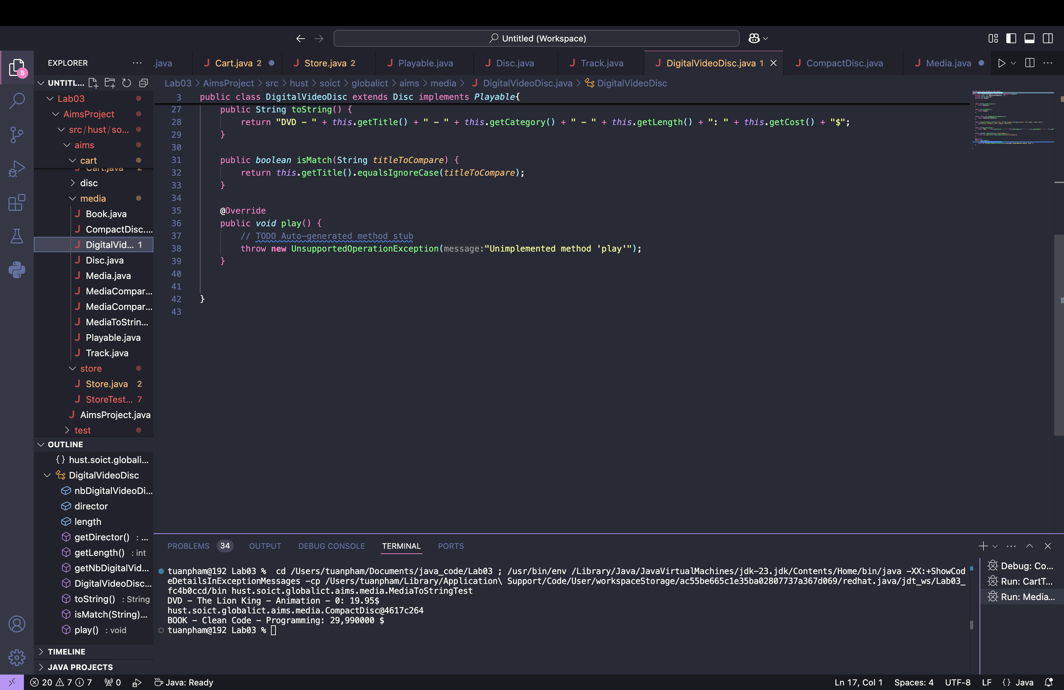

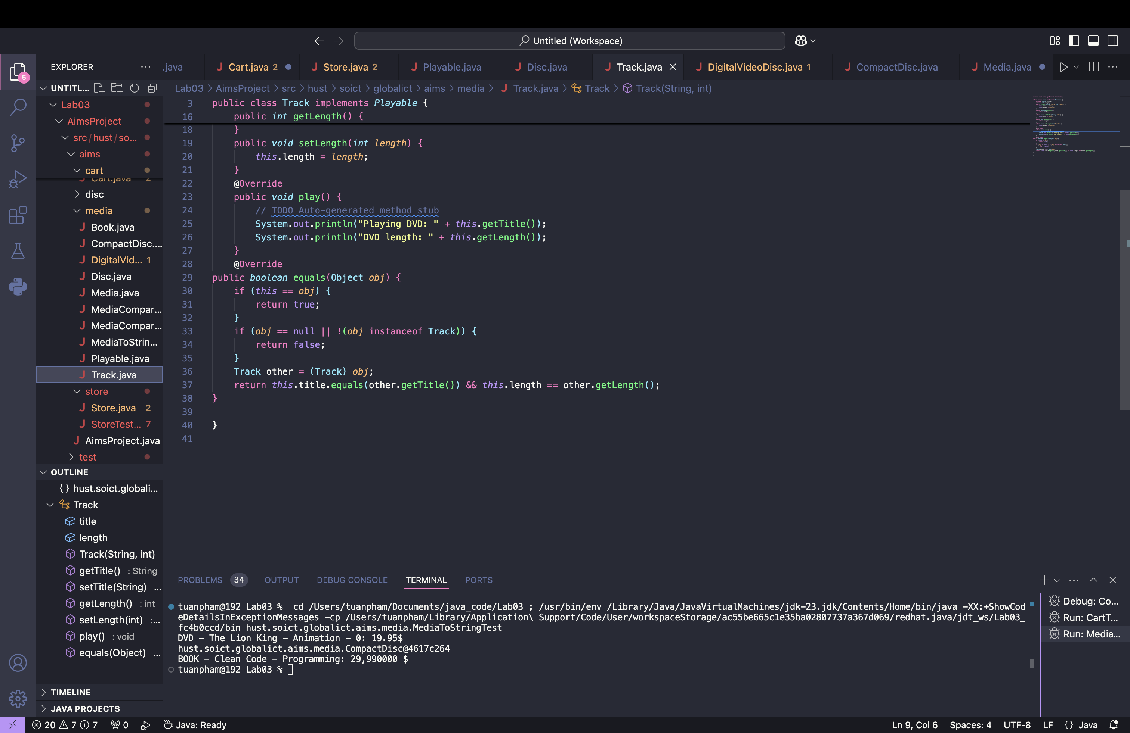

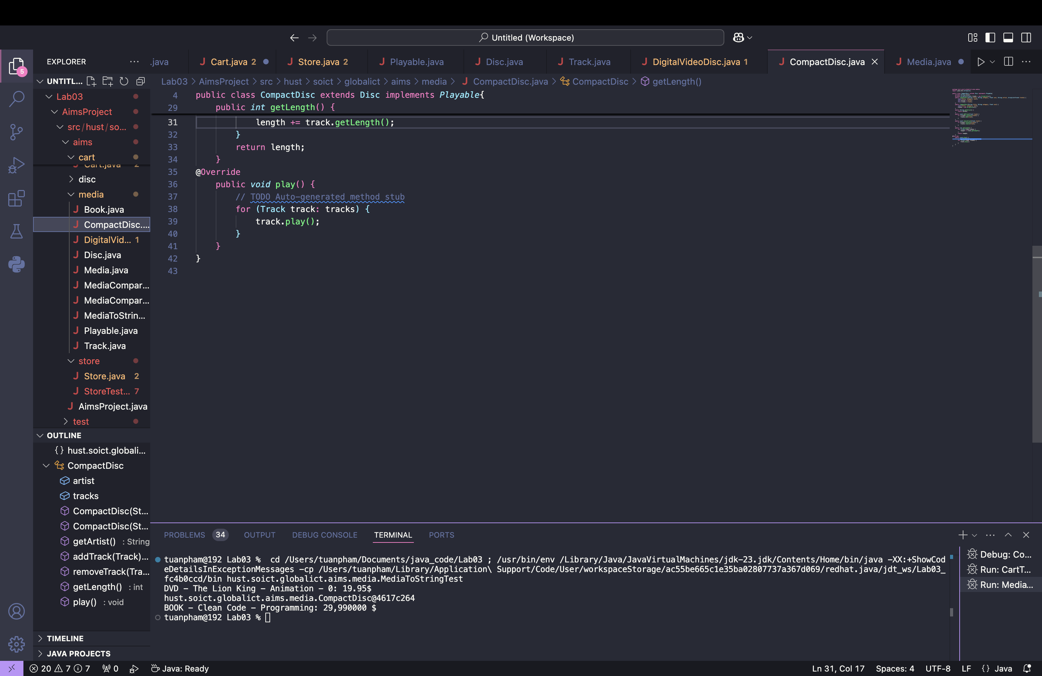

**12. Update the Cart class to work with Media**

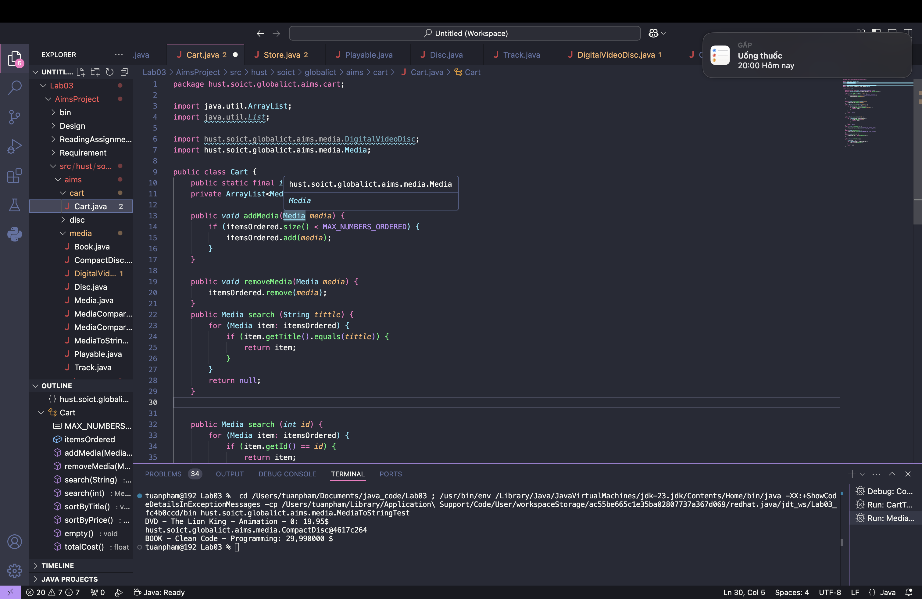

**13. Update the Store class to work with Media**

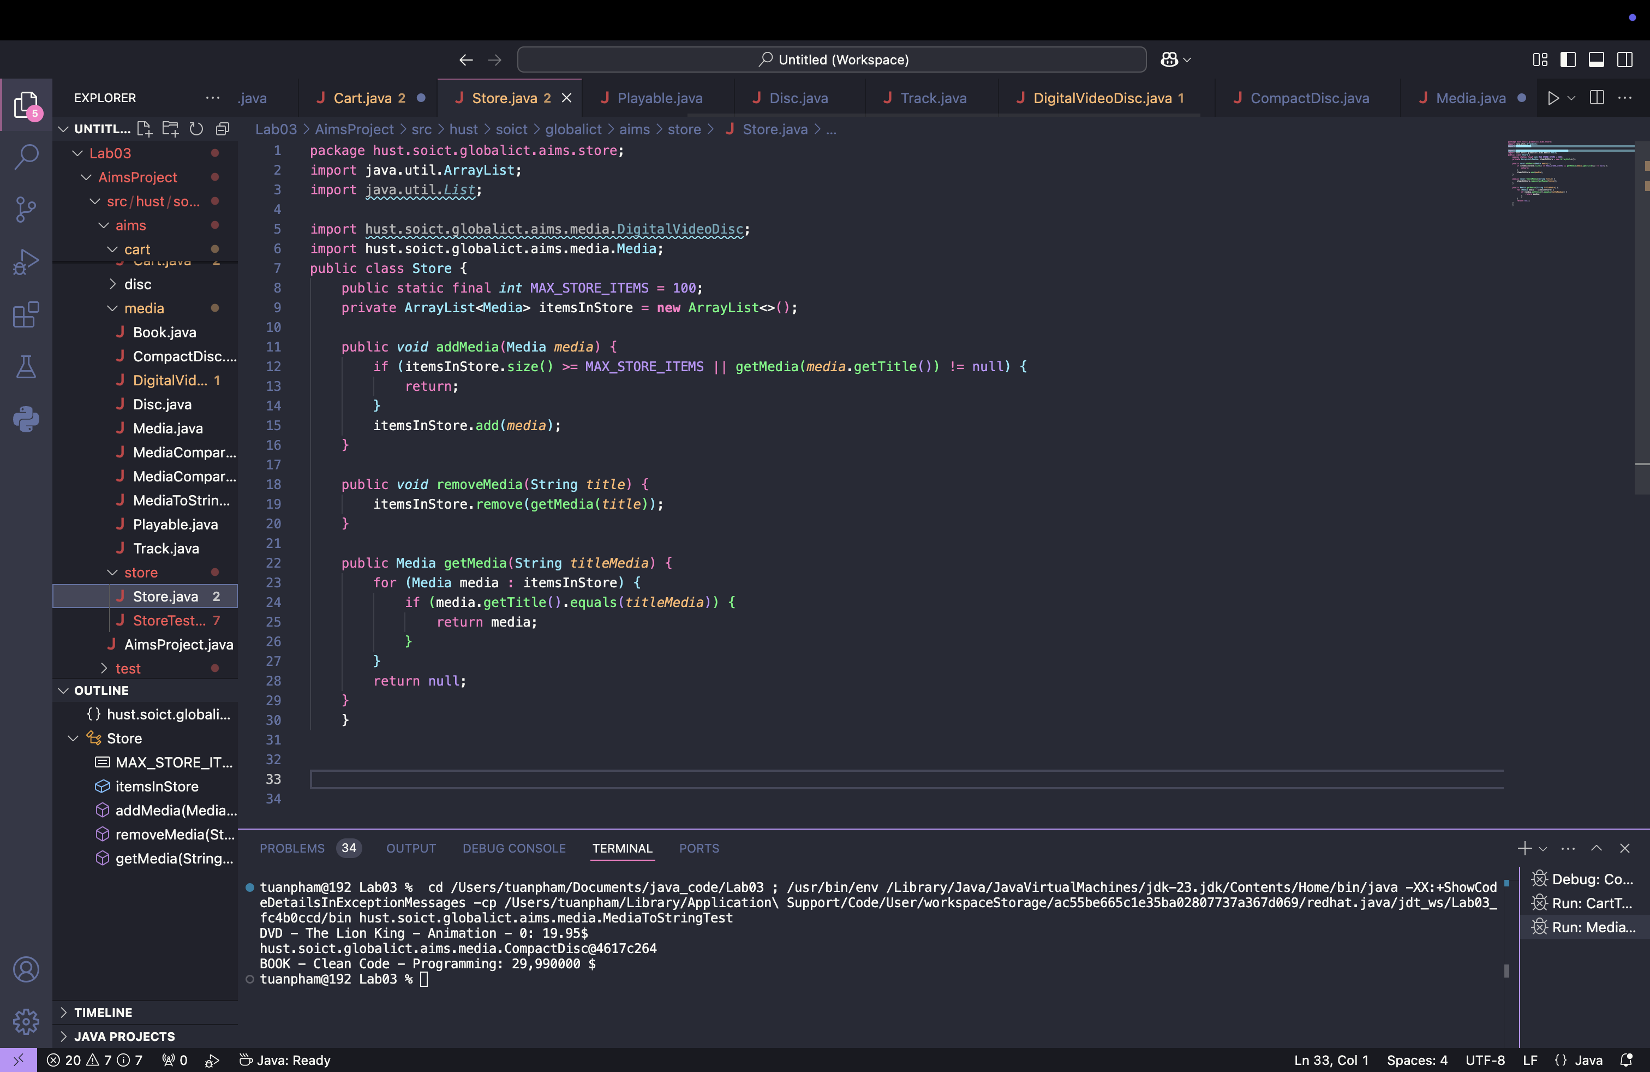

**14. Constructors of whole classes and parent classes**

In the AIMS Project, the CompactDisc, Cart, Store, and Book classes function as containers for other classes, with their associated lists correctly initialized in the constructors to prevent null references and ensure proper operation, where CompactDisc holds a list of Track objects, Cart and Store manage lists of Media, and Book contains a list of author names.

**15. Unique item in a list**

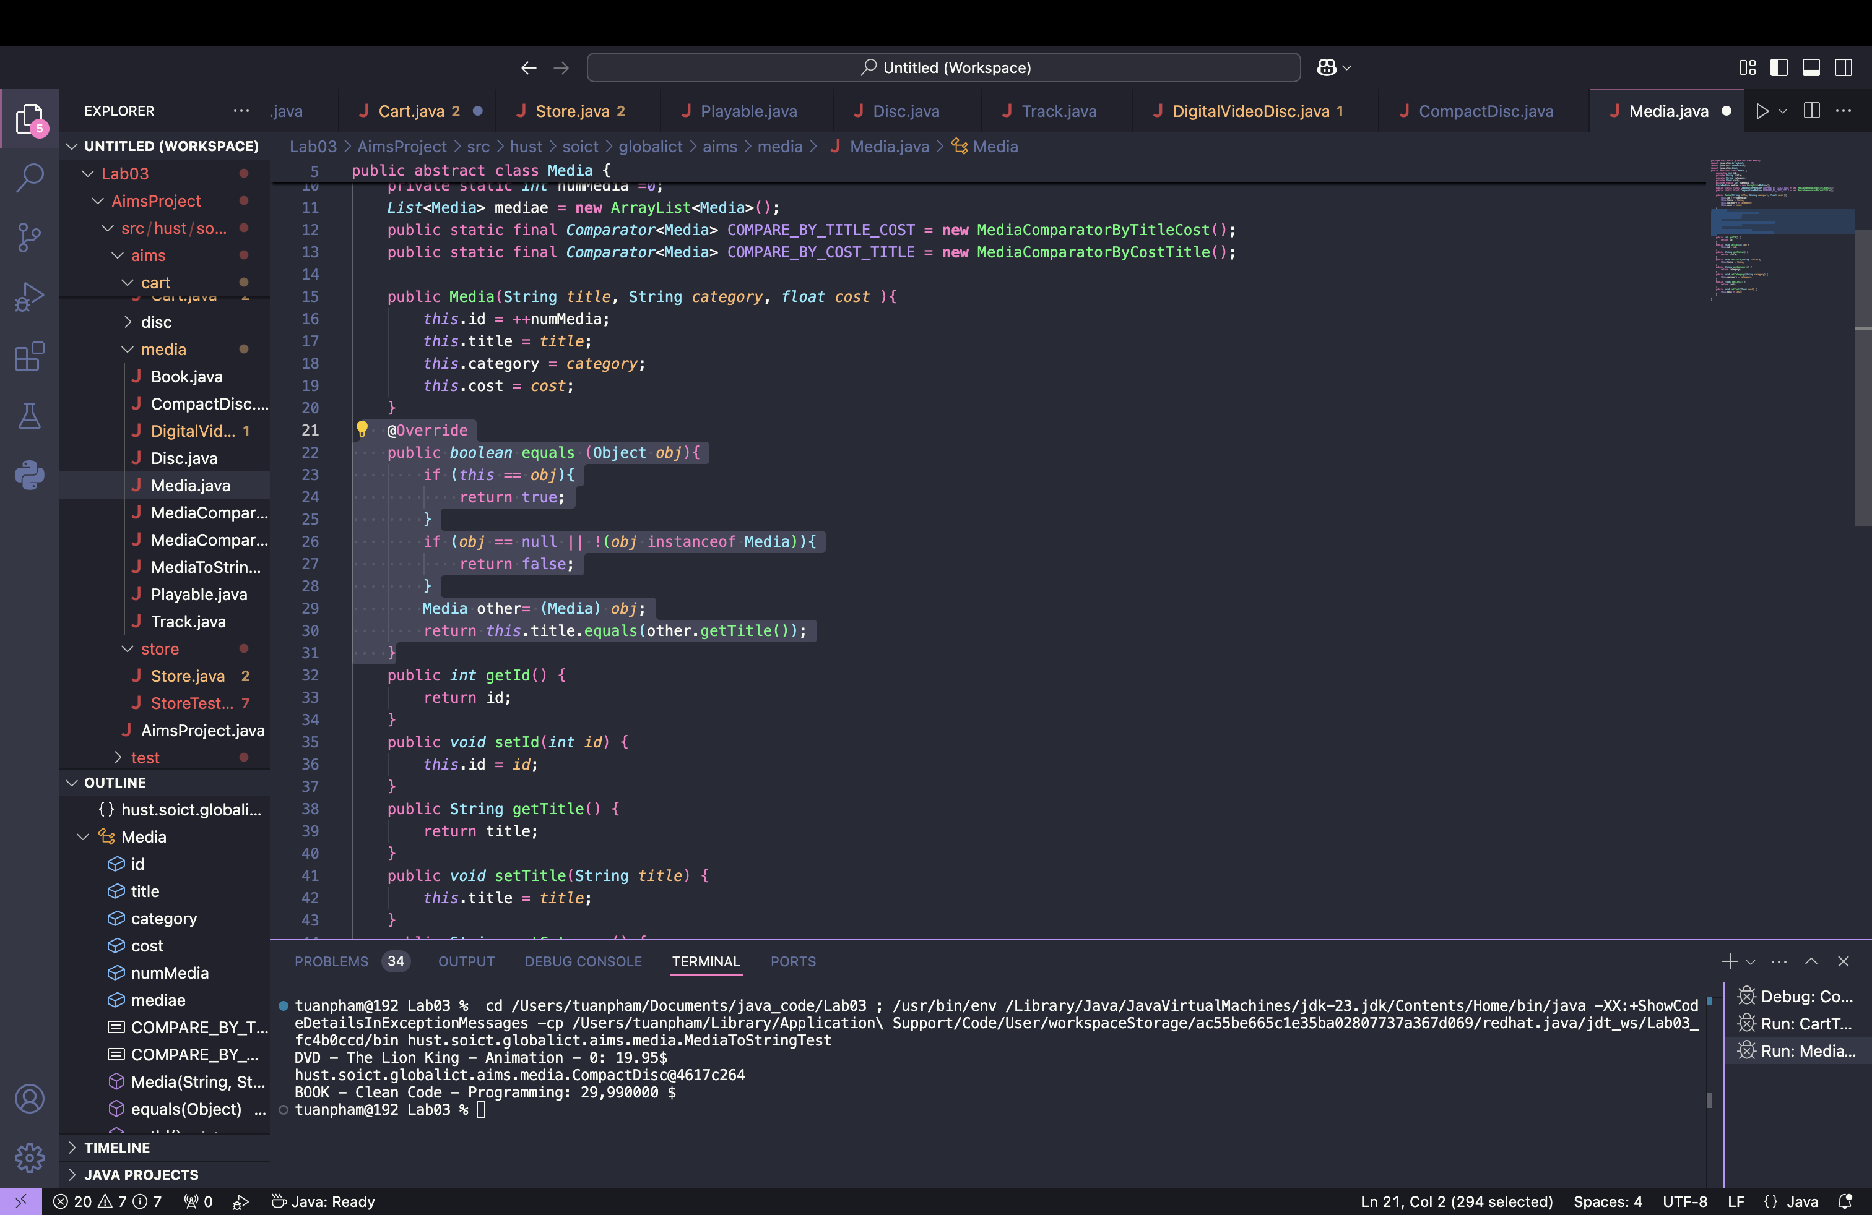

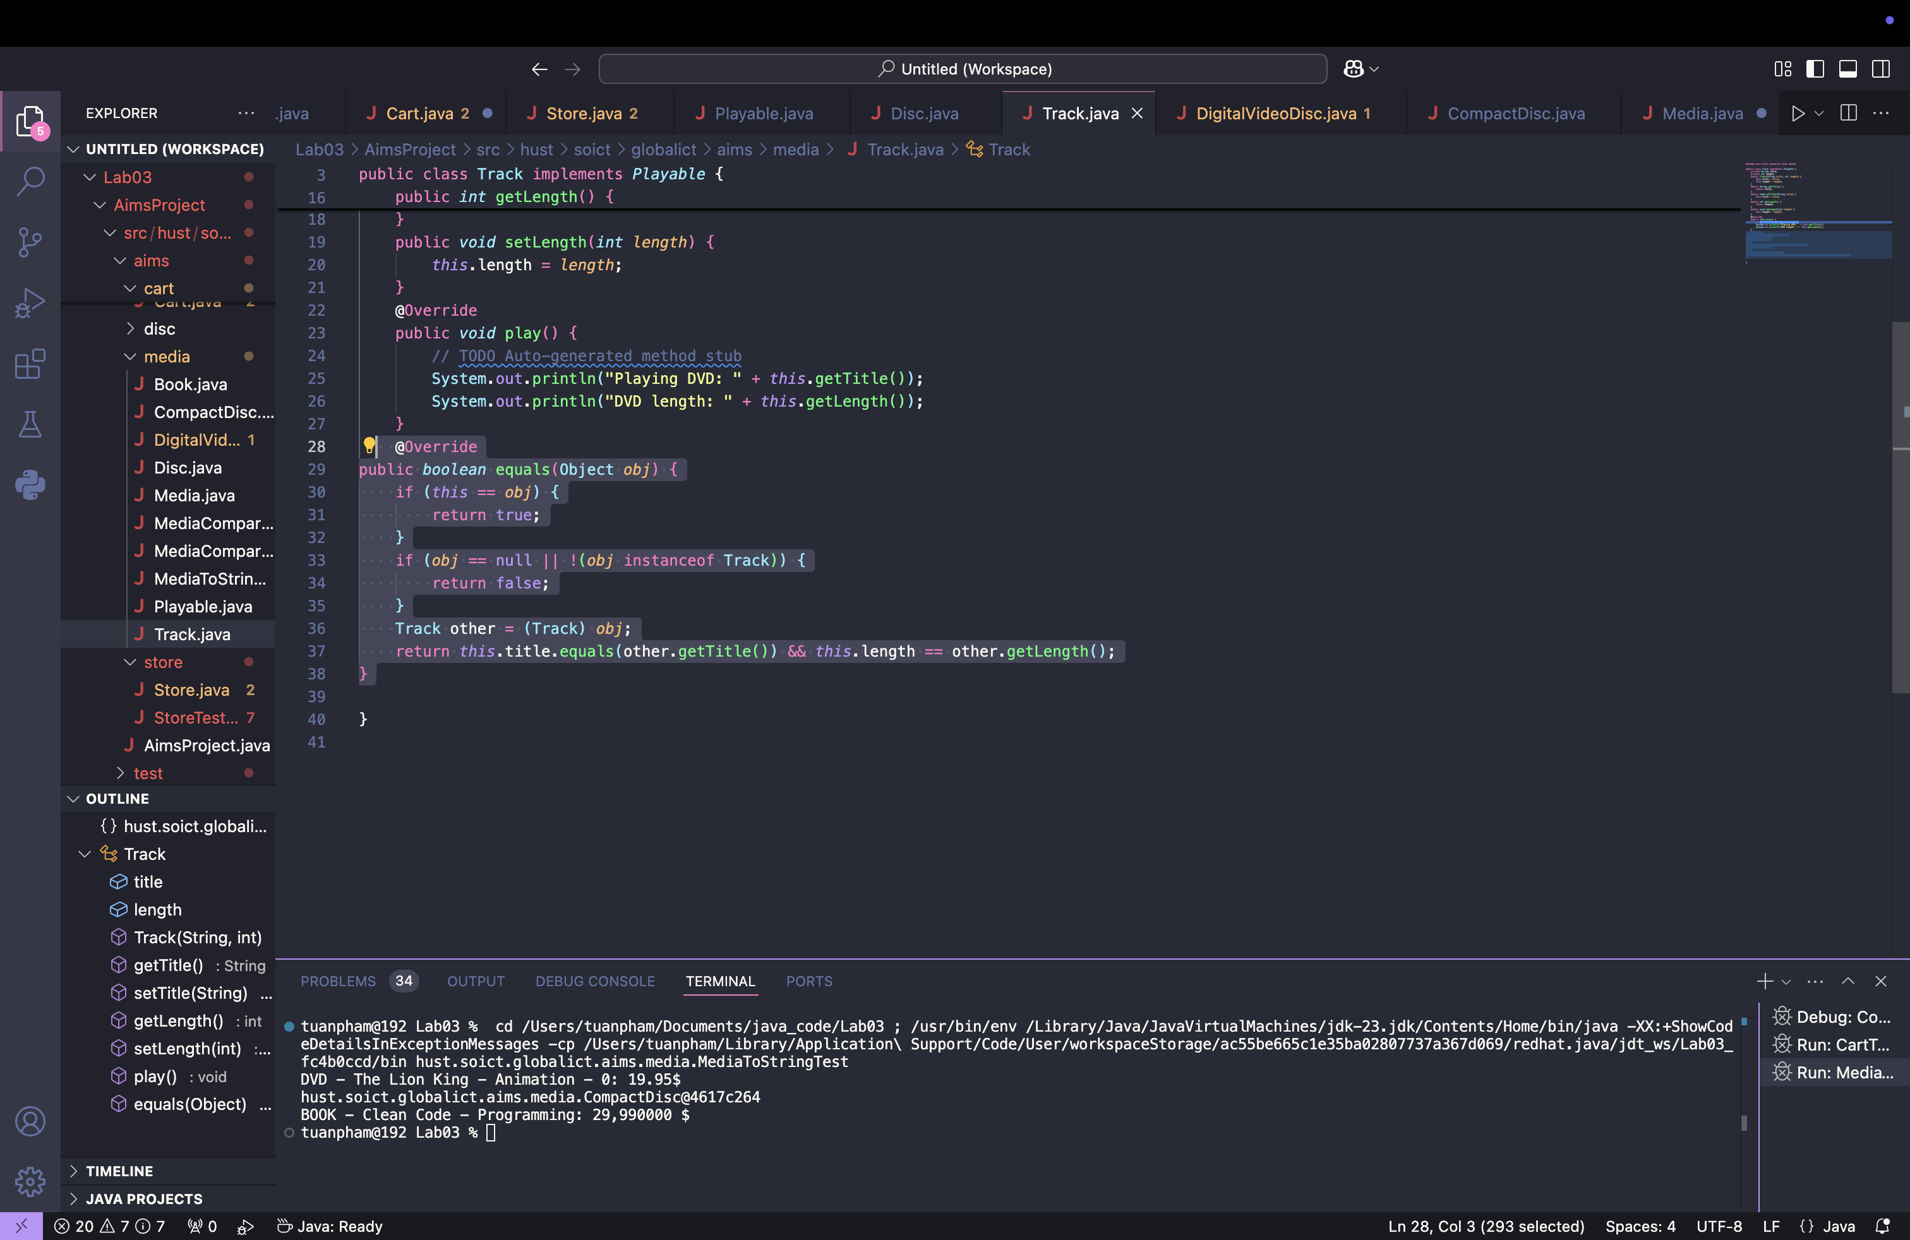

**If the passing object is not an instance of Media, what happens?**

**Answer:** When you override the equals() method and the parameter obj is not an instance of the class you're dealing with (e.g., not an instance of Media in the Media class), it will cause a ClassCastException if you try to cast it. To handle this properly, you should first check whether obj is an instance of the Media class (or Track for the Track class) before proceeding with the comparison.

If the object is not an instance of the expected class, the equals() method should return false, indicating that the objects are not equal. This prevents unnecessary exceptions and ensures that objects of different types are not considered equal.

**16. Polymorphism with toString() method**

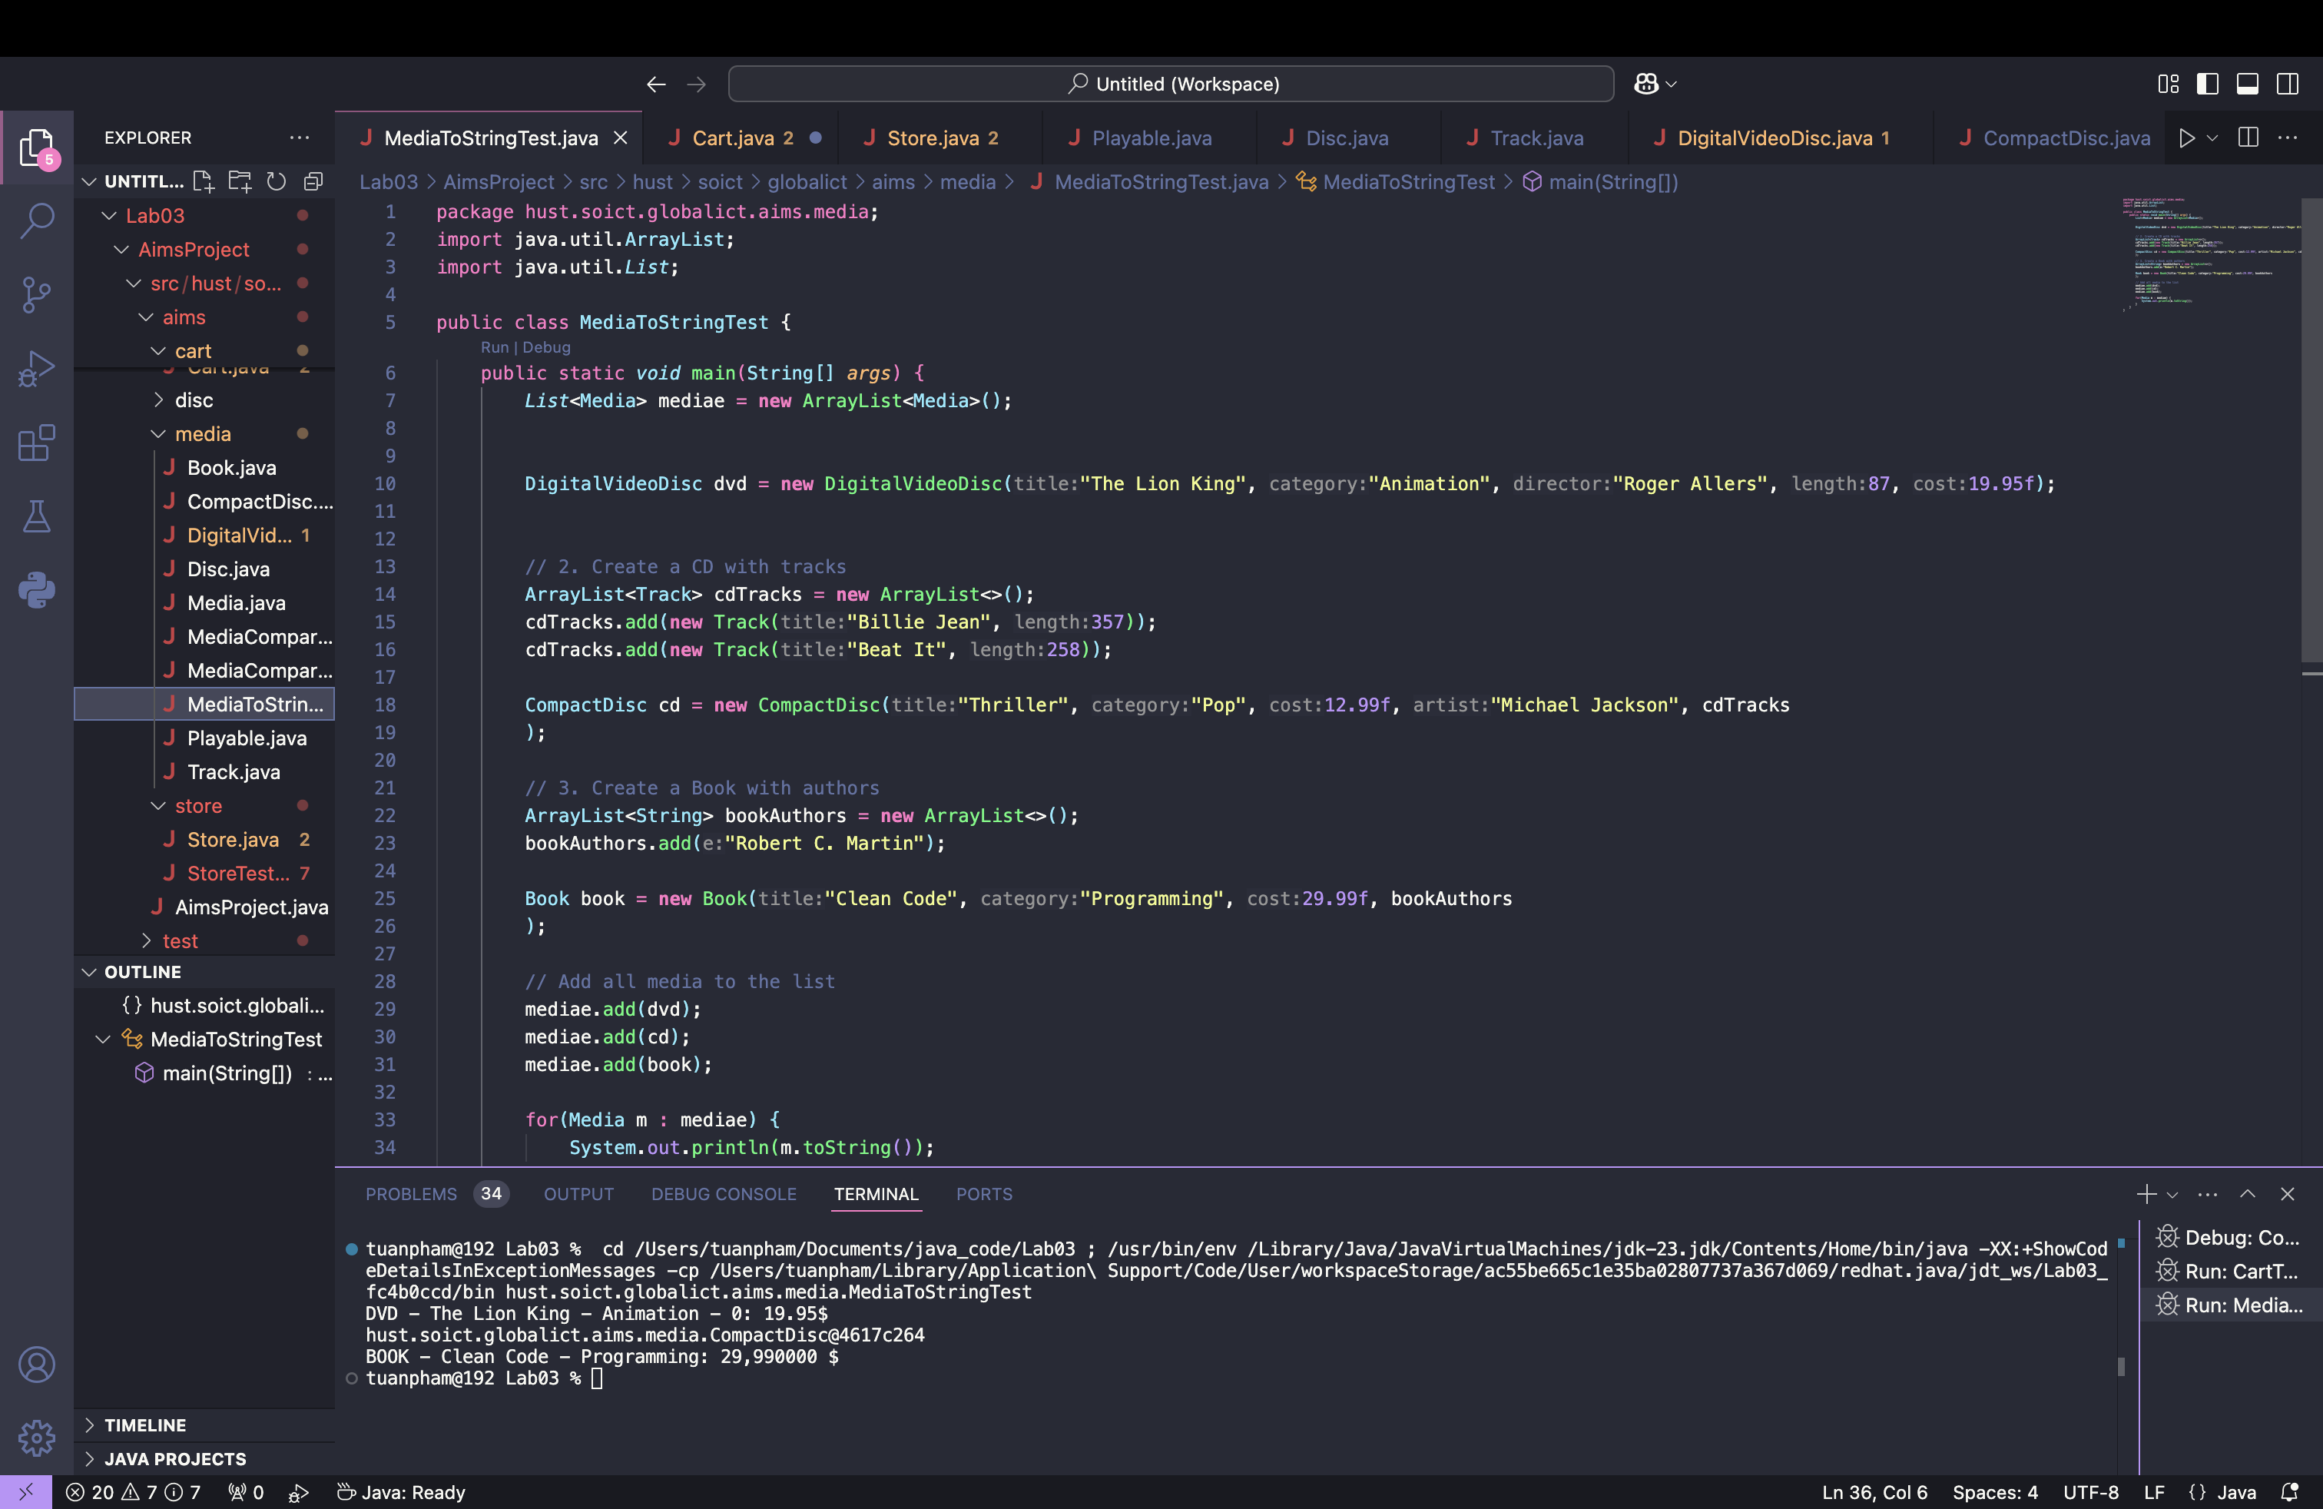

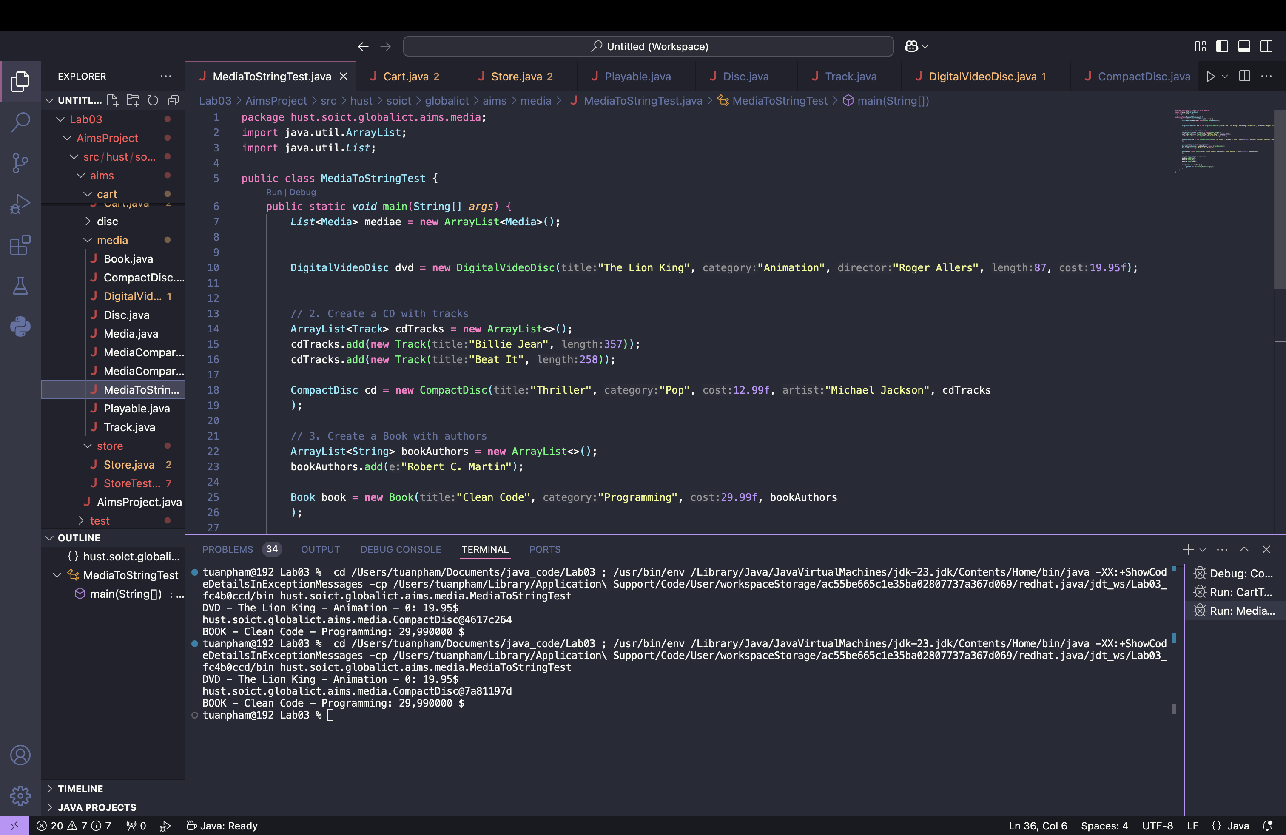

**Reading Assignment: Please answer three questions below:**

**- What are the advantages of Polymorphism?**

Polymorphism enables code reusability, flexibility, and maintainability, allowing methods to operate on objects of different types without needing to rewrite code. It also promotes cleaner, more readable code by allowing the same method to handle different object types dynamically.

**- How is Inheritance useful to achieve Polymorphism in Java?**

Inheritance enables polymorphism by allowing subclasses to override methods from a superclass. This lets the program dynamically choose the correct method based on the object's actual type at runtime, promoting flexibility and extensibility.

**- What are the differences between Polymorphism and Inheritance in Java?**

Inheritance allows one class to inherit the properties and behaviors of another, establishing a class hierarchy. Polymorphism, on the other hand, allows a single method to behave differently depending on the object type. While inheritance enables polymorphism, polymorphism focuses on method behavior, not class structure.

**17. Sort media in the car**

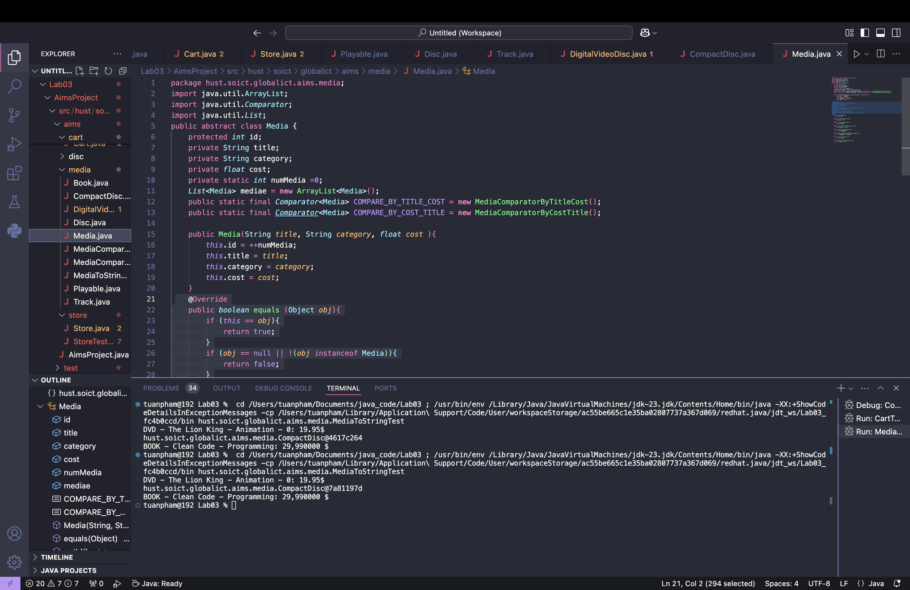

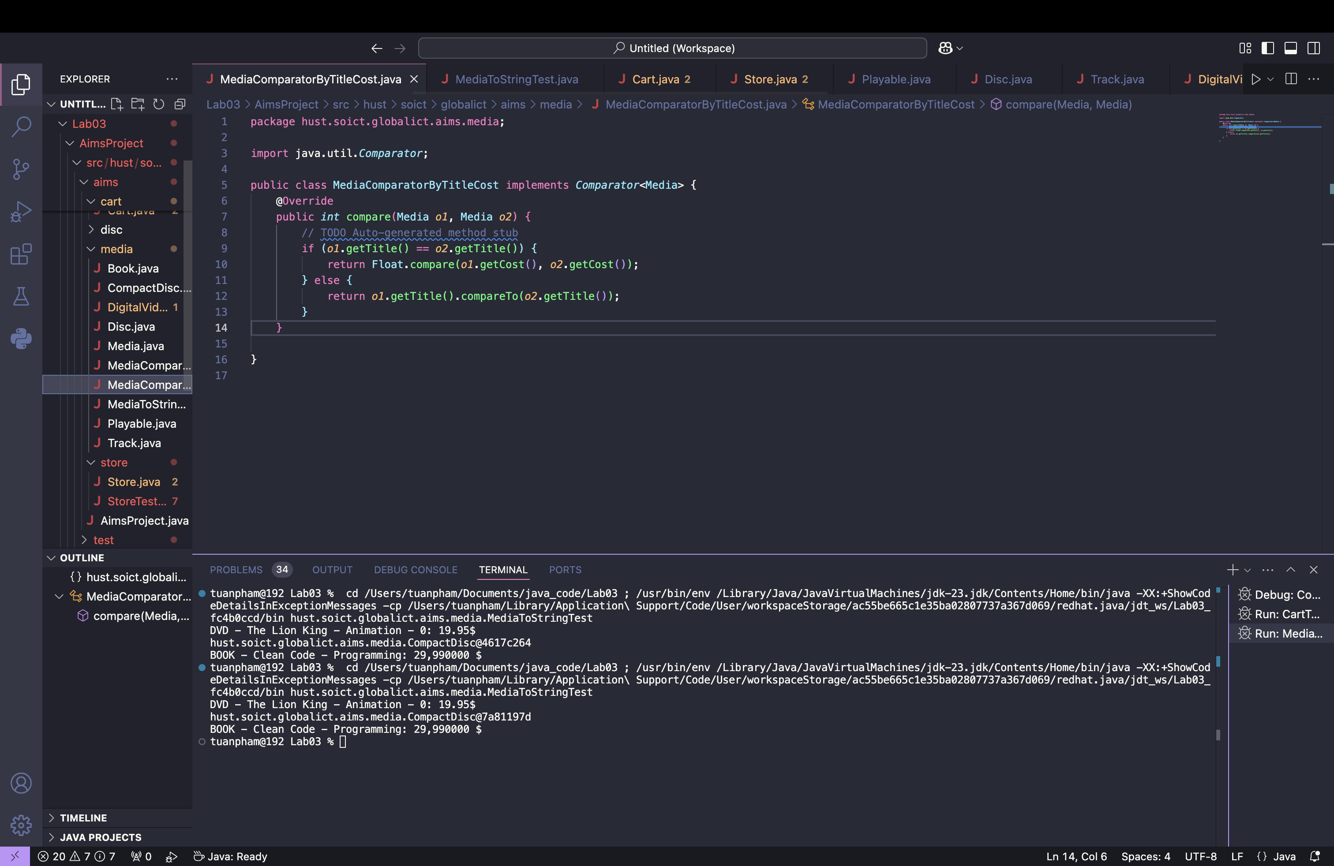

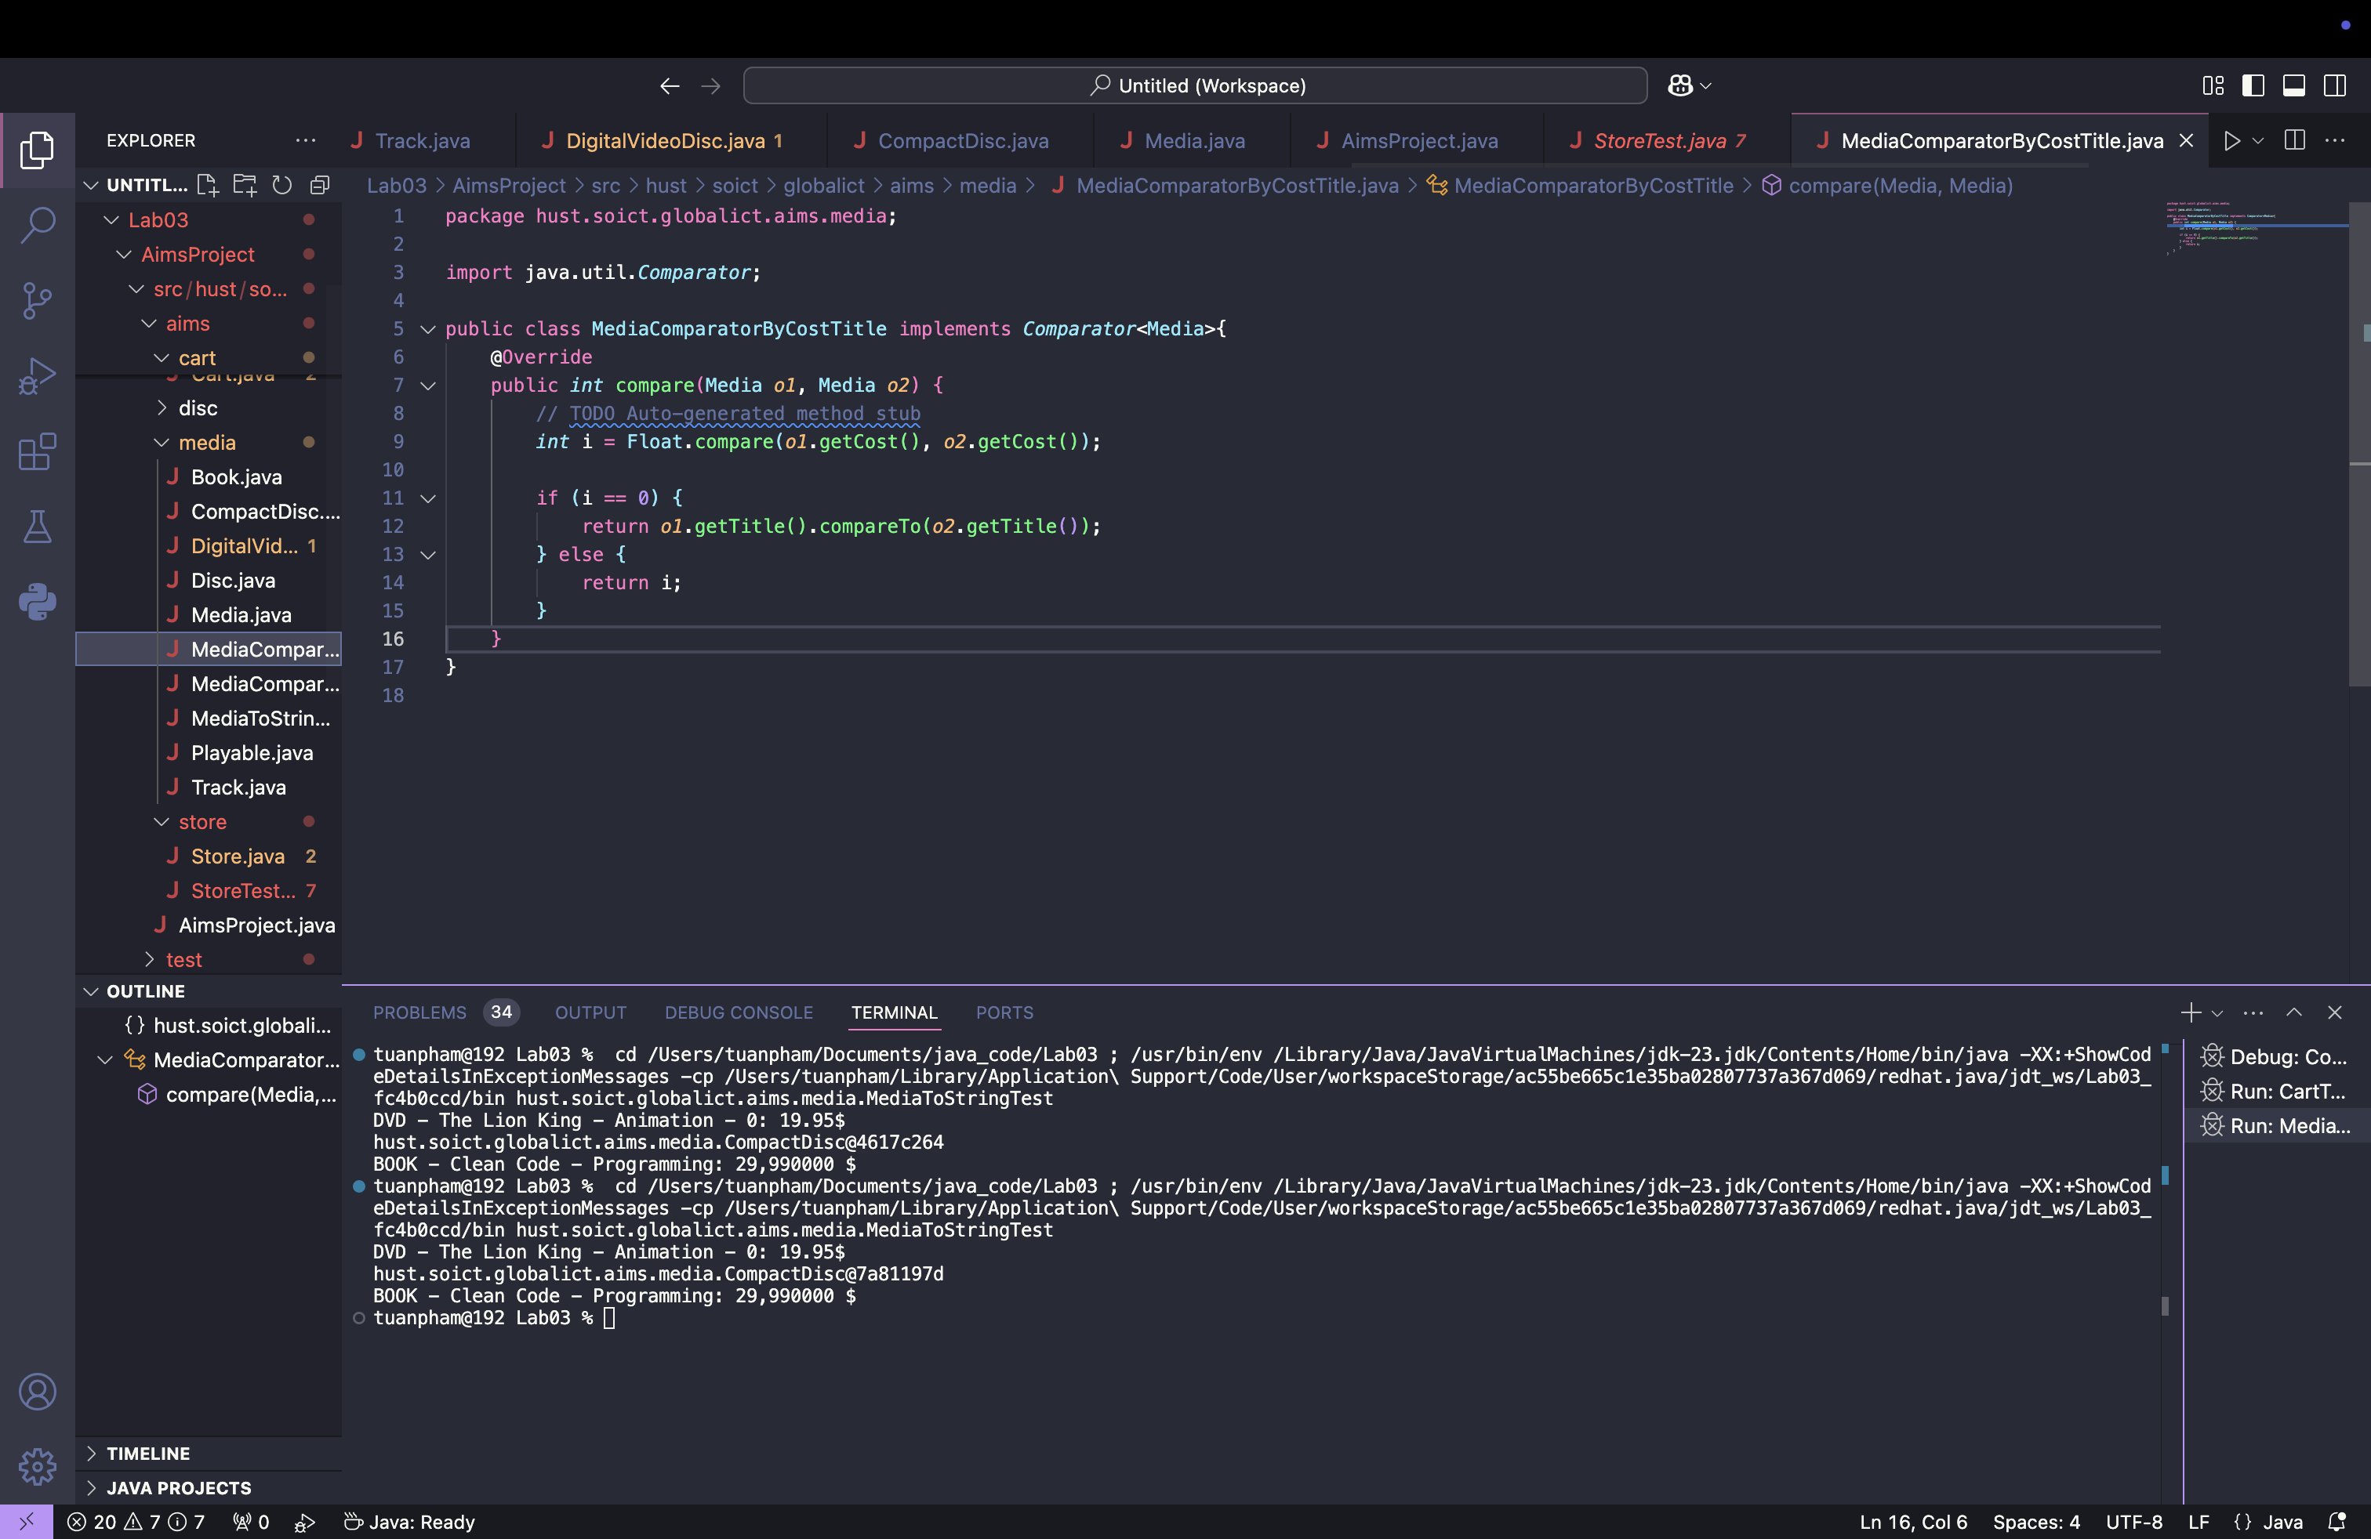

**- What class should implement the Comparable interface?**

The class that should implement the Comparable interface is the class representing the media items, which could be DigitalVideoDisc, Book, or CompactDisc. These classes should implement Comparable to define their natural ordering.

**- In those classes, how should you implement the compareTo()method to reflect the ordering that**

**we want?**

In the compareTo() method, you can implement the ordering logic based on the fields you want to sort by. For instance, if you want to sort by title first, followed by cost, you would do something like:

public int compareTo(Media other) {

// Compare by title

int result = this.title.compareTo(other.title);

if (result != 0) {

return result;

}

// If titles are the same, compare by cost

return Float.compare(this.cost, other.cost);

}

**- Can we have two ordering rules of the item (by title then cost and by cost then title) if we use this**

**Comparable interface approach?**

No, with the Comparable interface, you can only define one natural ordering per class. However, if you need multiple sorting criteria (like by title then cost and by cost then title), you should use the Comparator interface, which allows you to define multiple ways to compare objects.

**- Suppose the DVDs have a different ordering rule from the other media types, that is by title, then**

**decreasing length, then cost. How would you modify your code to allow this?**

To allow DVDs to have a different ordering rule, you can override the compareTo() method in the DigitalVideoDisc class specifically.

**18. Create a complete console application in the Aims class**

